

REPUBLIQUE DU CAMEROON
Paix-Travail- Patrie

REPUBLIC OF CAMEROON
Peace-Work-Fatherland

AFRICAN INSTITUTE OF COMPUTER SCIENCES - CAMEROON PAUL BIYA TECHNOLOGICAL CENTER OF EXCELLENCE
P.O. Box: 13719 Yaoundé
Tel: +237.242.729.957 Fax: 22729958
E-mail:contact@iaicameroun.com

REALIZE
Head Office: Yaounde – Ekie – Valley
Amadou
Tel: (237)620256960/654486985
Email:realize.contactus@gmail.com

Enterprise info
.[nb:it should end at the same
Level with that of IAI]

ACADEMIC INTERNSHIP REPORT

THEME:
Development of a Virtual Marketplace to Connect Vendors and Customers

Internship carried out from the 1st of July to the 30th of September 2025 at the company Realize as part of my pursuit to obtain a
Higher Technician Diploma (HTD) in Computer Science
Option: Software Engineering
Submitted by:
EKAANING EUCHARIA ANGWENUGEH
Level II Student at AICS Cameroon

Supervisors
Academic Supervisor :
Professional Supervisor :
Mr. TSEMBOM Percy
Software Developer at Realize
Mr. AGBOR Anderson
Head of Software Engineering

ACADEMIC YEAR:
2024-2025

DEDICATION

DEDICATION

THIS BOOK IS DEDICATED TO
THE EKAANING’S FAMILY

ACKNOWLEDGEMENTS

SUMMARYACKNOWLEDGEMENT

This work wouldn’t have been a success without the important contributions of a good number of people who took it upon themselves to see this work accomplished. Our sincere gratitude goes to the following:
- Mr. Armand Claude ABANDA, the Resident Representative of the African Institute of Computer Sciences, for his unwavering support and guidance.
- Mr. NDOLEHKA
- Mr. TSEMBOM Percy, my professional supervisor, for his availability, advices and moral support throughout the internship period which lead to the realization of this project.

- Mr. AGBOR Donald Anderson, my academic supervisor, for his warm welcome, encouragements, availability, tolerance, advices and moral support throughout the internship period.
- All our teachers at the African Institute of Computer Sciences for their support throughout our training.
- The amazing family at REALIZE for their endless love and support during this internship period.
- My family most especially my parents for their guidance and support without which we could not attain the end of this work.
- All our classmates and friends at AICS for their knowledge, ideas, collaboration and most importantly the unforgettable moments spent together.


SUMMARY

SUMMARY

LIST OF TABLES

LIST OF FIGURES

GLOSSARY

GENERAL INTRODUCTIONGLOSSARY

ABSTRACT

The rise of mobile commerce presents significant opportunities for small businesses and independent sellers to reach broader markets, yet many face barriers due to limited digital skills and costly platform access. This project develops a mobile marketplace application aimed at DEVELOPMENT OF A VIRTUAL MARKETPLACE that simplifies product listing, sales management, and buyer interaction. The app bridges the digital divide by offering essential features such as secure registration, product browsing, shopping cart, order tracking, and notifications all optimized for mobile devices. By lowering technological and financial hurdles, the platform fosters economic inclusion, enabling small-scale sellers to compete effectively in the digital economy while delivering customers a convenient, trustworthy shopping experience. This project focuses on simplicity, scalability, and real-world impact to create a sustainable tool that supports local commerce growth in an increasingly mobile-first world
Keywords:
- Customers
- Communication
- Connectivity
- Internet
- Vendors

RESUME

L'essor du commerce mobile offre aux petites entreprises et aux vendeurs indépendants des opportunités considérables pour atteindre des marchés plus vastes. Pourtant, nombre d'entre eux se heurtent à des obstacles liés à des compétences numériques limitées et à un accès coûteux à la plateforme. Ce projet DEVELOPPE UNE APPLICATION DE MARKETPLACE MOBILE visant à autonomiser les vendeurs locaux en leur fournissant une plateforme accessible et conviviale qui simplifie la création de listes de produits, la gestion des ventes et l'interaction avec les acheteurs. L'application comble la fracture numérique en offrant des fonctionnalités essentielles telles que l'inscription sécurisée, la navigation produit, le panier d'achat, le suivi des commandes et les notifications, le tout optimisé pour les appareils mobiles. En réduisant les obstacles technologiques et financiers, la plateforme favorise l'inclusion économique, permettant aux petits vendeurs d'être compétitifs dans l'économie numérique tout en offrant aux clients une expérience d'achat pratique et fiable.

Mot-Cle :
Clients
Connectivité
Communication
Internet
Vendeurs

GENERAL INTRODUCTION

The integration of Information and Communication Technology (ICT) across various industries has significantly enhanced productivity, speed, and efficiency. The African Institute of computer sciences (AICS) in fulfilment of its mission to train African engineers in Africa and for Africa put in place a three-month internship period for level two and three students. This period gives students the opportunity to put into practice skills acquired in school in a professional milieu and to further develop their problem-solving and engage in ideas skills through assistance in companies. We did our internship at "REALIZE" which is a growing company in the field of computer engineering whose mission is to provide IT solutions and Realize Dreams. At REALIZE, we were assigned on the theme “DEVELOPMENT OF A VIRTUAL MARKETPLACE”. Based on our theme we were required to make concrete research in order to bring out some solutions and challenges.To ease understanding, we divided this document into eight (8) parts. These are:
- Insertion Phase: Here we shall talk about our host company, their services, mission, as well as our first two weeks at our host company.
- Existing System: Here, we shall present the already present system in place,that is the one used for consultation and follow-up purposes.
- Specification Book: In this book, we specify the needs of the user, taking into consideration the time and cost of the project.
- Analysis Document: Here, we shall present the analysis method chosen, together with the presentation of all the diagrams used for the analysis of this project.
- Conception phase: This presents the generic and detailed conception of the project to bring out real-world constituents.
- The Realization phase: This phase will permit us to visualize the implementation process of the solution.
- Test of functionalities: In this phase, we shall present to you the different functionalities or modules of our application and how they work.
- The User Guide: This elaborates on all conditions necessary to use the application and how to use it.

PART ONE: INSERTION PHASE

Preamble

The insertion phase document outlines the internship setting, the organizational framework, the circumstances surrounding the interns' reception, and the project to be undertaken during the internship.

Content :

INTRODUCTION
- WELCOME AND INSERTION
- GENERAL PRESENTATION OF REALIZE
- ORGANISATION OF REALIZE
- HARDWARE AND SOFTWARE RESOURCES OF THE COMPANY
- GEOGRAPHICAL LOCATION
- BRIEF PRESENTATION OF THE PROJECT THEME

INTRODUCTION
The insertion phase in a company is a period during which we discover our working environment, the staff of the company and other interns. Here, we will begin by discussing our first two weeks in the company, how we were welcomed and how we began adapting to our internship environment, we will proceed by exploring the history of the company, discovering its missions, learning what its major activities are, and witnessing some of its key realizations. We will also get to understand how the company is structured administratively and functionally so that it operates effectively and accomplishes its goals. Furthermore, we will look at the hardware equipment used by the company, and the software resources used in its daily operations. We will then introduce our chosen theme for the internship period, briefly elaborate on it.

I. WELCOME AND INSERTION
We arrived at REALIZE on Monday 01st July 2024, at 08:00 a.m. we were received by the director of the IT department, Mr. TANUE MONETTE, who introduced us to our workspace, gave us an official welcome to the enterprise, its activities and its different rules and regulations. Also, we discussed on the enterprise’s preferred languages and frameworks, our professional supervisor encouraged us through his past working experiences in different enterprises. He also gave us the program that is from 08:00a.m. till 05:00p.m.
The first week we did Design thinking and Presentation. There was a talk on project ideas, we were advised to propose project ideas and we were assigned the tasks to carry out research on these ideas. The objective was that the enterprise did not want to impose some themes on us.
The second week we proceeded with verification of JavaScript concepts with some exercises, to test our reasoning and understanding faculties. We also discussed about the specification book with our professional supervisor and its different components, with him explaining what was required from us in each component. We discussed further on our different project ideas to give it shape.

II. GENERAL PRESENTATION OF REALIZE

a. Background
Realize is a Cameroon based non-governmental tech start-up institute founded by NDELOGAKEH Daniel in 2022 which proposes IT solutions and empowers the use of new technologies in Cameroon.

b. Missions
The mission of Realize mainly relates to the empowerment and the perpetuation of Technology use. These include:
• Design and realize mobile-oriented software for companies and individuals.
• Assist newborn companies for quick growth using computer sciences.
• Provide training and certifications to improve qualified human resources in many fields of study.
• Take an active part in the sustainable development of the world through innovative solutions and virtual reality.

c. Vision:
At Realize, we believe that the true potential of every organization and individual can be unlocked through the harmonious fusion of analysis, development, realization, and data analytics. Our vision propels us forward, guiding us to make a lasting impact on the digital landscape and shape a future where innovation knows no bounds.

d. Activities:
The activities of Realize range from computer sciences, engineering, and training. We can outline the following:
• Conception, realization and hosting of websites.
• Software development and Maintenance.
• Training in Software related fields.
• Conception and realization of multimedia.
• IT consulting and innovation.
• IT support.

III. ORGANISATION OF REALIZE

A. Administrative Organization
Realize is administratively organized as follows:

The General management
This is the highest level of the company, which takes care of the following:
• Proper functioning of each department.
• Define project strategies.
• Provide leadership and guidance to the company’s employees.
• Makes critical decision that could affect the company’s operations or reputation.
• Severe as a point of contact for key stakeholders such as investors etc.

Human resource department
This department is in charge of the following:
• Recruitment and Hiring.
• Acts as a liaison between employees and management;
• Manages employee compensation and benefits programs;
• Develops and implements company policies and procedures, ensuring compliance with employment laws and regulations
. • Manages administrative tasks related to employee records, data management, and HR systems.

Communication department
This department is in charge of the following:
• Handles public relations activities, which involve managing the company’s reputation and image.
• Responsible for crafting and delivering messages to external stakeholders such as customers etc.
• It fosters effective communication within the company.
• They create and manage content across different platforms and channels.

Department of technical affairs
This department is in charge of the following:
• Responsible for developing and managing the company’s financial plans and budgets.
• Prepare and present accurate and timely financial reports to management, stakeholders, and regulatory authorities.
• Responsible for managing cost and expenses within the organization.
• Ensures compliance with tax laws and regulations. Etc.

Technical department
This department is in charge of the charge of the following:
• Managing the company’s technological infrastructure, including networks and hardware.
• Play a role in managing and maintaining the company’s data.
• Implementing and maintaining cybersecurity measures to protect the company’s digital assets from potential threats.
• Interacts with technology vendors and manages relationships with external service providers.

Software Engineering Department
This department is in charge of the following:
• Primarily responsible for developing software applications and systems.
• Responsible for maintaining and supporting software applications throughout their lifecycle.
• Evaluation and realization of projects etc.

B. FUNCTIONAL ORGANIZATION OF REALIZE
The functional branch of Realize is organized as follows
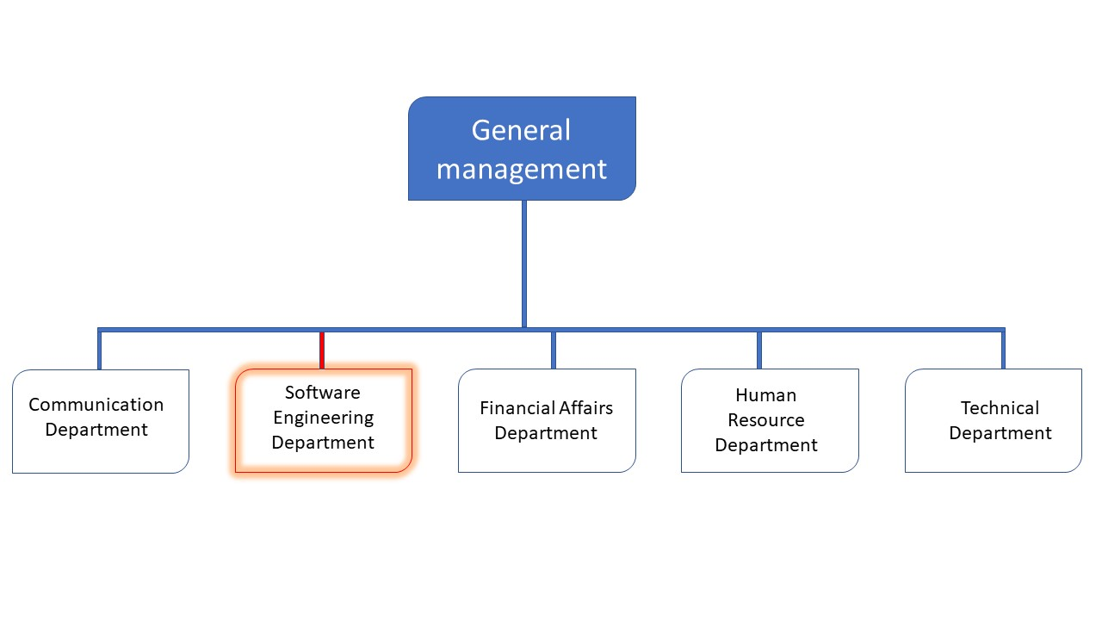

Figure 1: Functional organization of chart of realize

IV. HARDWARE AND SOFTWARE RESOURCES

HARDWARE RESOURCES
Table 1: Hardware resources of realize
No | DESIGNATION | QUANTITY | CHARECTERISTICS | OBSERVATION
1 | MacBook Pro | 1 | APPLE | Good
2 | Modem | 1 | CAMTEL | Good
3 | LCD Screen | 1 | HP | Excellent

B. SOFTWARE RESOUCES
Table 2: Software resources of Realize
DESIGNATION | SOFTWARE
Operating System | Windows 10, Mac OS, parrot Linux
Design tools | Photoshop
Integrated development environment (IDE) | Visual studio code
Text editor | Sublime text, notepad++
Database management system (DBMS) | MongoDB, PostgreSQL, MySQL
Web browser | Google chrome, Microsoft edge
Document editor | Microsoft office word

V. GEOGRAPHICAL LOCATION

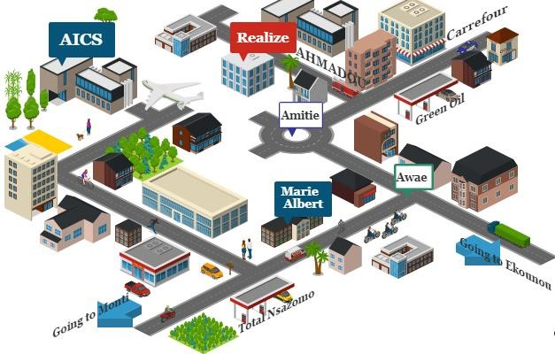
Figure 2: Geographical location

VI. BRIEF PRESENTATION OF PROJECT

At the end of the initial two weeks (insertion period), we received a topic, namely DEVELOPMENT OF A VIRTUAL MARKETPLACE. This project involves developing a platform designed to connect vendors and buyers in a digital world where sellers can promote and analyze their businesses while the buyers benefit from local discovery and the ability to support community businesses.

CONCLUSION
Our insertion phase at REALIZE lasted for two weeks. During this time, we discovered the remarkable environment we were in, which encourages hard work, perseverance, and collaboration; qualities that many students seek. We learned about the company's missions and activities, and we had the opportunity to meet and connect with the staff and other interns at …. As a culmination of this phase, we were assigned the theme “DEVELOPMENT OF A VIRTUAL MARKETPLACE”

PART TWO: TECHNICAL PHASE

Preamble

The insertion phase helped us to establish a comprehensive understanding of the host organization. This phase emphasizes the key characteristics, specificities, and objectives of the designated study subject.

Content :

INTRODUCTION
- The Existing System
- The Specification Book;
- The Analysis Phase
- The Conception phase
- Deployment phase or Realization phase
- The Functionality Testing Phase;
- The User Guide.
CONCLUSION

FILE ONE: EXISTING SYSTEM

Preamble

The existing system refers to the established processes currently used. This documentation outlines how these processes function, including their limitations and any resulting problems. We aim to address these issues by proposing a new solution.

Content:

INTRODUCTION
- PRESENTATION OF THE THEME
- DESCRIPTION OF THE EXISTING SYSTEM
- CRITICISM OF THE EXISTING SYSTEM
- LIMITATIONS OF THE EXISTING SYSTEM
- PROBLEMATIC
- PROPOSED SOLUTIONS
CONCLUSION

INTRODUCTION
Engineers are problem-solvers dedicated to making life easier for society. Before proposing solutions, it is essential to first understand the root causes of problems and how they are currently being addressed. By carefully analyzing existing systems within our field, we can identify the gaps and challenges that still remain. This critical examination allows us to design solutions that are both practical and innovative. In doing so, we ensure that our proposals improve upon or effectively replace the current systems for the better.

PRESENTATION OF THE THEME
The theme of this project is the DEVELOPMENT OF A VIRTUAL MARKETPLACE designed to create an online platform that facilitates seamless buying and selling of goods and services without the constraints of physical locations. The aim of our project connects buyers and sellers in a centralized digital environment, enabling users to browse, negotiate, and complete transactions efficiently and securely. The aim of our app is to support diverse product listings, user-friendly interactions, secure payment integrations, and real-time communication between parties. It empowers sellers by providing tools to showcase their products widely, while buyers benefit from a broad selection, transparent pricing, and convenient order management.
By applying digital technologies, this project seeks to address the growing demand for accessible and scalable ecommerce solutions, promote market inclusivity, and enhance the overall trading experience for both consumers and vendors. The app will play a critical role in enabling economic growth by bridging geographic and operational gaps traditionally limiting commerce.

DESCRIPTION OF THE EXISTING SYSTEM
In the current system, which heavily relies on platforms such as WhatsApp and Facebook, faces several significant challenges that limit its effectiveness. One of the main issues is the unpredictability of platform algorithms, which frequently change and directly affect the visibility of marketing content, forcing businesses to invest increasingly in paid promotions to maintain their reach. This lack of control over exposure undermines consistent engagement efforts.
Additionally, users on these platforms are inundated with a high volume of content and advertisements, creating a noisy environment where marketing messages often get lost, reducing overall impact. Managing an active social media presence also demands considerable time and resources, as marketers must continuously create and adapt content while monitoring changing platform policies.
Moreover, strict rules on bulk messaging, especially on WhatsApp, impose scalability limitations, while sudden policy shifts can disrupt ongoing campaigns. From the consumer’s perspective, the fragmented experience where browsing, communication, and purchasing happen across different channels creates friction that can lead to drop-offs and lost sales. Concerns about data privacy, misinformation and scams further exacerbate trust issues among users, complicating marketers’ efforts to build strong customer relationships. Lastly, the openness of social media means that negative feedback can quickly become public and viral, potentially harming brand reputations and requiring significant effort to manage.

LIMITATIONS OF THE EXISTING SYSTEM
Table 3: Limitations, Consequences, proposed solution
LIMITATIONS | CONSEQUENCE | PROPOSE SOLUTION
Unpredictable platform algorithms (WhatsApp, Facebook) | Reduced visibility of marketing content; increased spending on paid promotions | Build a dedicated virtual marketplace platform with controlled content visibility and consistent reach.
High volume of content and ads | Marketing messages get lost; reduced overall impact | Centralized platform for sellers to showcase products without competition noise
Strict rules on bulk messaging / scalability limits | Limits ability to reach large customer base; disrupts campaigns | Built-in messaging system for vendors to communicate directly with customers at scale
Fragmented consumer experience (browsing, communication, purchasing on different channels) | Customer drop-offs; lost sales | Unified platform combining browsing, communication, and purchase in one system
No admin oversight | Fake vendors and scams can easily happen | Admin monitoring to approve vendors and ensure quality.
Open social media exposure to negative feedback | Potential harm to brand reputation; high management effort | Controlled environment in marketplace; review and feedback system to manage reputation

PROBLEMATIC
Upon examining the current system, we have discovered certain limitations. These challenges result in the principal: HOW CAN CUSTOMERS AND VENDORS OVERCOME THE CHALLENGES OF TRUST, PAYMENT SECURITY AND EFFICIENT PRODUCT VISIBILITY BY USING A STRUCTURED AND RELIABLE VIRTUAL MARKETPLACE?.

PROPOSED SOLUTION
After our study and criticism of the existing situation, we proposed to design a mobile application that will allow the user (Vendors and Customers) of Cameroon to:
Vendors
- A secure platform to create and manage their online store
- Upload products with images, prices and descriptions.
- Increased visibility by reaching more customers through the marketplace.
- An analytics dashboard to track sales, earnings and customer activity.
Customers
- A verified marketplace to browse products from trusted vendors.
- Tools to search, filter and compare products easily.
- Order tracking and purchase history for better transparency.
- Secure payment where the money will be send to the vendor when his payment name matches with his id card.

CONCLUSION
Having reached the end of this part, we studied the existing system, which enabled us to come out with the limitations of the system that led to the consequences, and we proposed solutions to the various limitations. Finally, we proposed our solution, which is a mobile application. This step is necessary because we need to understand how the system put in place currently works before we can facilitate or ameliorate the processes being carried out in this system.

FILE 2: SPECIFICATION BOOK

Preamble

The Specification book is a document that is established by the customer needing a particular product and the producer (engineer) who is to create the product, which is to be respected to its fullness during the realization of the product. From this, we obtain the major importance of the specification book.

Content :

INTRODUCTION
- CONTEXT AND JUSTIFICATION
- PROJECT OBJECTIVES
- EXPRESSION OF NEEDS
- PROJECT PLANNING
- ESTIMATED COST OF THE PROJECT
- LIST OF PARTICIPANTS
- PROJECT CONSTRAINTS
- DELIVERABLES.
CONCLUSION

INTRODUCTION
The specification book of our report helps us provide details about our theme to improve our understanding of it and increase the likelihood of its success. To delimit the scope of our project, we will specify the context of our theme. From the context, we will list the problems we have decided to address throughout the project. After presenting our solution, we will talk about the objective we have set for the project. Also, we will explore the needs to which our system will respond, both at the functional and non-functional level. We will then look at the estimated financial requirements for our project and establish a plan we will follow to complete our project on time. From here, we will discuss what is expected of us by the end of the project under the project deliverables.

CONTEXT AND JUSTIFICATION

Context
Small business owners and individual sellers often rely on social media platforms like WhatsApp and Facebook to promote and sell their products
However, these platforms present significant challenges, such as unpredictable algorithm changes, over marketing and transactions. Vendors struggle to reach their target audiences, while buyers face uncertainty and inconvenience in their shopping journeys. Recognizing these obstacles, the Virtual Marketplace project proposes an integrated online platform designed to provide a seamless, secure and trustworthy environment where sellers and buyers can interact directly. By combining product browsing, communication, negotiation, payment, and order management in one centralized space, this solution addresses the major limitations of social media marketing and empowers users with greater control, efficiency, and confidence in online commerce.

Justification
The primary justification for this project stems from the urgent need to address the limitations of existing social media platforms used for online selling. Social media channels often subject sellers to unpredictable algorithm changes, high competition, restricted promotional opportunities and fragmented purchasing experiences that lead to lost sales and decreased user trust. Buyers frequently encounter security concerns, confusing communication, and multiple steps just to complete a purchase. The Virtual Marketplace project is essential because it offers a purpose-built, integrated platform where transactions are more transparent, secure, and efficient. By centralizing product discovery, communication, payment, and order management, it empowers sellers with greater control over their business and enhances convenience and confidence for buyers. This solution stands to improve engagement, increase sales conversion, and build lasting trust making it a much-needed and timely advancement for digital commerce.

OBJECTIVES OF THE PROJECT

GENERAL OBJECTIVE
. To develop a secure and efficient virtual marketplace that enhances trust, transparency and accessibility between vendors and customers while improving online trade management.

SPECIFIC OBJECTIVES
- To design and implement a user-friendly interface that allows vendors to list products and customers to browse and purchase them easily.
- To ensure secure transaction by integrating payment gateways and data protection measures.
- To improve products and order management for vendors with tools for tracking inventory, sales and delivery status.
- To increase accessibility and reach by making the platform available across devices and regions

EXPRESSION OF NEEDS

Functional Needs
These are the requirements that a system must meet to fulfill its purpose.

Vendors
- Profile Management: Create and verify seller accounts to build trust.
- Product Listing: Add and manage product/service details, prices, and inventory.
- Order Management: Track and fulfill orders, handle returns and disputes.
- Communication: Interact with buyers for inquiries and negotiation.
- Analytics: Access sales data to optimize performance and marketing.
- Secure Payments: Receive payments through trusted gateways.

Buyers
- Account Creation: Register for personalized and secure shopping.
- Search & Browse: Easily find products with filters and categories.
- Shopping Cart & Checkout: Add items and pay securely with multiple options.
- Order Tracking: Monitor order status and transaction transparency.
- Communication: Contact sellers to ask questions or negotiate.
- Reviews & Ratings: Provide feedback to help other buyers.

Admins
- User Verification: Approve and verify vendors and buyers for platform integrity.
- Content Moderation: Manage product listings and remove inappropriate content.
- Transaction Monitoring: Oversee payments, prevent fraud, and resolve disputes.
- Platform Configuration: Set policies, fees, and operational settings.
- Reporting: Generate analytics to monitor platform health.
- Community Management: Enforce guidelines to maintain trust and safety.

Non-Functional Needs
They specify the quality attribute of a software system. They judge the software system of an application based on Performance, Responsiveness, Usability, Security, Portability, and other non-functional standards that are critical to its success. Failing to meet non-functional requirements can result in a system that fails to satisfy user needs.
Performance, Scalability, and Security
Performance defines how fast a software system, or its piece, responds to a certain user’s action under a certain workload. In most cases, this metric indicates how long a user must wait before the target operation occurs (such as the page rendering or a transaction being processed) given the overall number of users at that moment. But it’s not always like that. Performance requirement may describe background processes invisible to users. Our goal is to provide our users with the best performance, which in turn enhances the overall user experience.
Scalability refers to the highest workloads under which the system will still meet the performance requirements. In this project, we will mainly leverage the power of cloud storage and third-party API’s. The application should have a friendly user interface (UI) and should be easy to use. The code should be clear to facilitate future development and improvement. The web application should be resizable when opened on any device (Android phone, computer, tablet, web browser.
Security is also one of the most important aspects of any system, especially those dealing with sensitive users’ information. The application should provide a strong security mechanism to reassure users that they can trust it for their sensitive information. Some of the security principles include reassuring confidentiality, accountability, Integrity, and Authentication.

PROJECT PLANNING

Chronogram of activities
We began our internship on the 1st of July, till the 30th of September 2025, a total of 3 months. To this, it was an obligation for us to manage our time properly so as to finish on time. This section presents how the work phases were scheduled throughout my internship period
Table 4: Chronogram of activities
Task | Duration(days) | Period
Produce an insertion document | 2 weeks | 1th July to 12th July
The Existing System | 1weeks | 14th July to 19th July
Production of Specification Book (with corrections) | 1weeks | 21th July to 26th July
Analysis of the solution and drafting of the analysis document (with corrections) | 2weeks | 28th July to 9th August
Conception | 2 weeks | 11th August to 23th August
Realization | 3 weeks | 25th August to 13th September
Functionality Test | 1 week | 15th September to 20th September
Writing User Guide | 1 week | 22th September to 26th September

Gantt Project planning

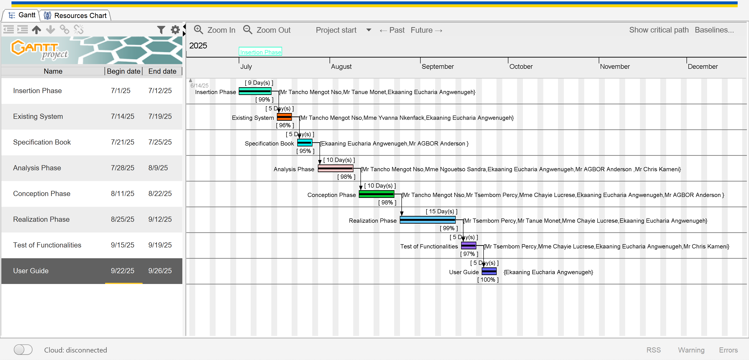

ESTIMATED COST OF THE PROJECT

Software Resources
For the realization of this project, we will need the following software application.
Table 5: Software Resources
RESOURCES | DESIGNATION | USAGE | QUANTITY | UNIT COST (FCFA)
Formatting | Microsoft Word 2016 | Writing of the report | 1 | Freemium
GitHub | GitHub | Saving our documents | 1 | Freemium
Web browser | Google Chrome | View web pages | 1 | Freeware
Code Editor | Visual Studio code | For writing the code of the application | 1 | Freeware
Project planning | Gantt Project | For building a Gantt chart | 1 | Freemium
Illustrating tool | Ichogram | For building a geographical location of the enterprise | 1 | Freemium
UML Analysis | Visual paradigm | For drawing UML diagrams | 1 | Freemium
Testing Mobile App | Expo Go | For testing the mobile application | 1 | Freemium
TOTAL 1 |  |  | 8 | /

Hardware Resources
This includes the material resources used to realize this project. The table below shows a representation of these different materials:

Table 6: Hardware resources
Hardware Resource | Quantity | UNIT COST (FCFA)
Laptop | 1 | 320,000
Printer | 1 | 185,500
Mobile phone | 1 | 80,000
Removable Disk | 1 | 4000
MODEM | 1 | 20,000
TOTAL 2 |  | 609,500

Human resources
Table 7: Human Resources
ROLE | NUMBER OF DAYS | QUANTITY | COST PER DAY | TOTAL PRICE (FCFA)
Project Manager | 90 | 01 | 30,000 | 2,700,000
Analyst | 21 | 01 | 25,000 | 525,00
UI/UX Designer | 30 | 01 | 10,000 | 300,000
Programmer | 30 | 01 | 15,000 | 450,000
Tester | 14 | 02 | 10,000 | 280,000
TOTAL 3 |  |  |  | 5,730,000

Global Estimation
Table 8: Global Estimation
TOTAL 1(FCFA) | TOTAL 2(FCFA) | TOTAL 3(FCFA) | Unexpected charges (10%) {(Total cost) * 10% } | OVERALL TOTAL (FCFA)
/ | 609,500 | 5,730,000 | 633,950 | 6,973,450
SIX MILLION NINE HUNDRED AND SEVENTY-THREE THOUSAND FOUR HUNDRED AND FIFTY

LIST OF PARTICIPANTS
The table below presents the different persons who took part in the accomplishment of this project. They include:
Table 9: List of participants
Names | Functions | Role and Tasks
Mr. TSEMBOM Percy | Software Developer | Professional Supervisor
Mr. AGBOR Anderson | Head of Software Engineering at AICS-Cameroon | Academic Supervisor
Mr. TANCHO Mengot Nso
Mr. TANUE Monet
Mme Nguestso Sandra
Mme Chayie Lucrese
EKAANING EUCHARIA ANGWENUGEH | Level two Student at AICS-Cameroon | Project head, analyst, conception and coding of project, testing

PROJECT CONSTRAINTS
To put in place this application, we must respect three main constraints, which include:
- Budget Constraint: The fixed budget for the realization of this project must be strictly respected.
- The Deadline Constraint: the realization of this system must respect the deadline attributed to it and should be completed in three months (3), including respecting the fixed objectives of the project.
- Quality Constraint: after fixing the budget and a deadline, we must produce a flexible, standalone, and reusable applications.

DELIVERABLES
In project management, any component materializing the 1. In project management, any component materializing the result of a realization service is called a deliverable. In the case of our project, the deliverables are: A report composed of the following document:
- A User Guide
- Software Application
- PowerPoint

CONCLUSION
To conclude, the specification book has allowed us to present the general and specific objectives of the project, as well as the project constraints. It also details the functional and non-functional requirements of the system and lays out the different resources needed for the project. Additionally, it provides a clear project planning framework to guide development. The document serves as a solid foundation for the next step of drafting the analysis document. This will help highlight the technical aspects of the project as a whole.

FILE 3: THE ANALYSIS PHASE

Preamble

The analysis document that adheres to the specifications provides a comprehensive overview of the issue and the proposed solution, supported by diagrams. It outlines the selected analysis method for the project and explains the rationale behind this choice. All of these elements contribute to a clearer understanding of the information system being modeled.

Content:

INTRODUCTION
- METHODOLOGY
- COMPARATIVE STUDY BETWEEN MERISE AND UML
- PRESENTATION OF THE 2TUP
- CHARACTERISTICS OF THE 2TUP
- JUSTIFICATION OF THE CHOICE OF THE ANALYSIS
- MODELING
- USE CASE DIAGRAM
- COMMUNICATION DIAGRAM
- SEQUENCE DIAGRAM
- ACTIVITY DIAGRAM
CONCLUSION

INTRODUCTION
Analysis involves breaking down a problem into its components to enable effective computer processing. Conducting a thorough analysis is essential to ensure the project meets the objectives outlined in the specification document. The success of the project largely depends on the quality of this analysis. Without proper analysis, the project is unlikely to achieve favorable outcomes. Therefore, careful and detailed analysis is a critical step in the development process.

METHODOLOGY
Analysis is the fundamental step in the conception of software. It is the basis for the realization of every information system. An information system is an organization of resources (human, software, and hardware), data, and feedback to attain a specific objective. Several methods and languages have been put in place to facilitate the analysis and conception of information systems, which principally have UML and MERISE.

COMPARATIVE ANALYSIS BETWEEN MERISE AND UML

MERISE
MERISE stands for “Méthode d’Etude et de Réalisation Informatique pour des Systèmes d’Entreprise”. Although it is prescriptive to some extent, MERISE permits the participation of end users and senior management as well as data processing professionals in its decision cycle. MERISE is a method for designing, developing and carrying out IT projects. The goal of this method is to achieve the design of an information system. The MERISE method is based on the separation of data and processing to be carried out in several conceptual and physical models. The essentials of the approach lie in its three cycles: the decision cycle, the life cycle and the abstraction cycle, which cover data and process elements equally. The separation of data and processing ensures longevity in model. Indeed, the arrangement of data does not have to be often overhauled, while treatments are more frequently.

UML
UML (Unified Modelling Language) is a standard notation for the modelling of real world objects as a first step in developing an object-oriented design methodology. Its notation is derived from and unifies the notations of three object-oriented design and analysis methodologies: Grady Booch's methodology for describing a set of objects and their relationships, James Rumbaugh's Object-Modelling Technique (OMT), Ivar Jacobson's approach which includes a use case methodology. Other ideas also contributed to UML, which was the result of a work effort by Booch, Rumbaugh, Jacobson, and others to combine their ideas, working under the sponsorship of Rational Software. UML captures information about the static and dynamic view of a system. UML 2.5 comprises of 14 diagrams which represent the different views of a system. The 14 diagrams can be subdivided into two, Static or structural and Dynamic diagrams. These diagrams include;

STATIC OR STRUCTURAL DIAGRAMS
- Class diagram;
- Object diagram;
- Component diagram;
- Deployment diagram;
- Composite Structure diagram;
- Package diagram;
- Profile Diagram;

BEHAVIOURAL OR DYNAMIC DIAGRAMS
- Use case diagrams;
- Activity diagram;
- State machine diagram;
- Sequence diagram;
- Communication diagram;
- Global Interaction diagram;
- Timing Diagram;
These diagrams can be represented on the diagram below:
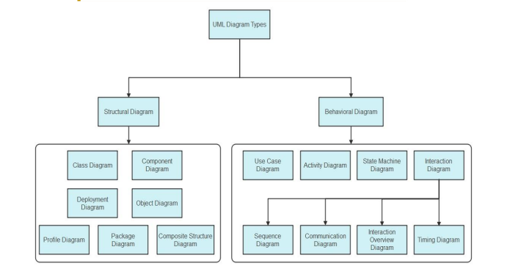
Figure 3 UML Architecture
Source: https://images.edrawsoft.com/articles/what-is-uml/uml-diagram-types.png

Table 10: Comparative analysis between MERISE and UML
MERISE | UML
Méthode d’Etude et de Realization Informatique pour les Systèmes d’Entreprise | Unified Modeling Language
Merise is a method of analysis. | UML is a modeling language
Merise is a systematic method of analysis and design for information systems, i.e., it uses a system approach. | UML is, however, not a method but rather an object-oriented language, uses the 2TUP approach to model a system
It is based on a procedural approach | Based on object approach
Merise proposes to consider the real system from two points of view:  • The Static view(data)  • The Dynamic view (treatments). Which means in Merise, we have a separate study of data and treatments | UML offers a different approach from that of MERISE in that it combines data and process

PRESENTATION OF THE 2TUP
2-TUP (Two Track Unified Process) is Y in shape and is a unified process that has as its objective to bring a solution to constraints of functional changes imposed on information systems. It proposes a development cycle that separates the functional aspects from the technical aspects. 2-TUP therefore distinguishes two main branches :
(The functional and technical branch) whose different results are being merged to realize our system.
Any unified process UP (Unified Process) process meets the following characteristics:
- It is iterative and incremental.
Some of the advantages of the 2TUP include:
- It allows the addition of modules.
- It allows flexibility in the analysis of a project.
- It is easy to design and understand.
- It allows to have a preliminary view
Below is the representation of 2-TUP:

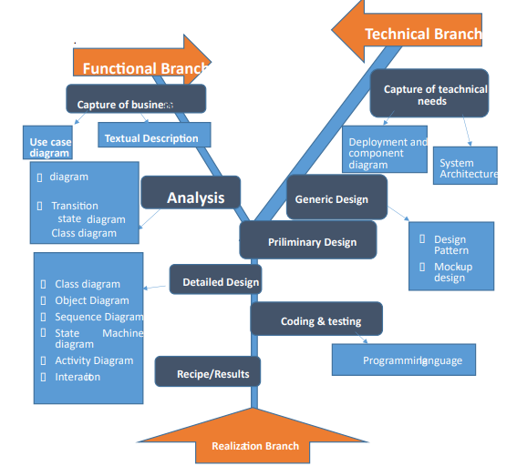
Figure 4 : 2TUP diagram

The Functional Branch:
This branch captures business needs, resulting in a model focused on the end-user’s requirements.

The Technical Branch:
This branch proposes a generic design from the technical needs, identifies the materials, tools, and technologies to be used.

The Implementation:
The implementation phase consists of bringing the two branches together, providing the application design, and finally the delivery of a solution adapted to the needs.

Functional Branch (left branch)
- Capture of Business Needs: This part minimizes the risk of producing an inadequate system with the needs of users and also verifies its consistency.
- Analysis: This is the study of the specifications to find out what the system will be made of in terms of the business rules. We have the following diagrams: Use Case, Activity Diagram, State Machine Diagram, and Communication Diagram.

Technical Branch
- Capture of Technical Needs: This stage consists of the identification of tools, materials, and technologies to use in developing the system. This technical architecture will be presented in this stage.
- Generic Designs: The technical architecture will be presented in this stage. We have the following diagram: mockUp7 Design.

Implementation Branch (middle branch):
- Preliminary Branch: This is the stage where the analysis model is integrated into the technical architecture. The goal here is to know what technical component will be used depending on the features of the analysis. We have the following diagrams: interaction overview, Component, Deployment, package diagram and Composite Diagram.
- Detailed Design: this is the detailed design of each feature of the system. We have the following diagrams: class, object, sequence and timing Diagrams.
- Coding and Testing: This is the programming phase of the designed features, alongside testing of the coded features.
- Recipe (Result): This is the validation phase of the functions of the system developed.

CHARACTERISTICS OF 2TUP
The two-track unified process was built to be used with the Unified Modeling Language to become a method and has the following characteristics:
- It is user oriented: 2TUP is built from user’s expectation
- It is component-oriented: it offers flexibility to the model by supporting the re-use of components.
- It is an iterative process: processes are being done in iterations, and each iteration shows a precise level of abstraction.
- It is an incremental process: allowing a better functional and technical risk management and thus constituting the deadlines and the cost control.

JUSTIFICATION OF THE CHOICE OF THE ANALYSIS
Our choice was based on the modeling language UML, associated with it 2TUP, due to certain criteria, which are as follows:
- UML is based on an object-oriented approach;
- UML associates data and treats it;
- It is a modeling language that focuses mainly on users’ needs and expectations;
- 2TUP is a process built from an object-oriented approach and is built from UML.
- 2TUP facilitates the modeling of complex systems, which can further be readjusted.

MODELLING

USECASE DIAGRAM

DEFINITION
The use case diagram simply shows the relationship between the actors of the system and the system. It permits users to easily visualize the different actions that can be done by the users. It also clearly defines the boundaries of the system.

FORMALISM
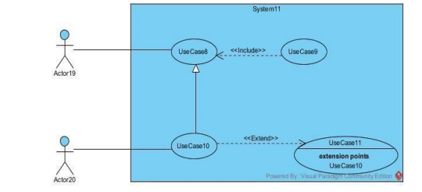
Figure 5: Formalism of a use case

COMPONENTS OF USE CASE DIAGRAM
Table 11: Component of use case
Elements | Notation | Notation
Actors | 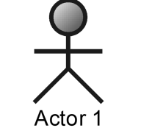 | Represents an entity that directly interacts with the system. The actor is what performs the  different possible actions of the system
Use case | 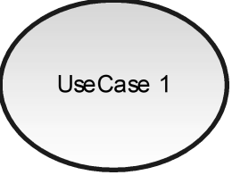 | A use case represents a functionality of the system. It is an action that can be performed by an actor.
Association | 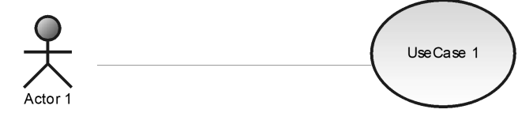 | It indicates that an actor takes part in a use  Case.
Include | 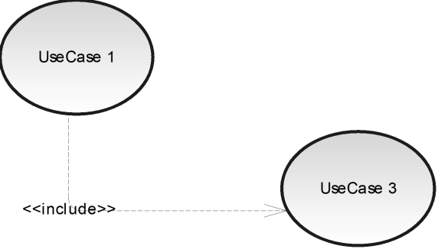 | An inclusion denotes that an included action must be  performed  before the including action can be performed.
Extend | 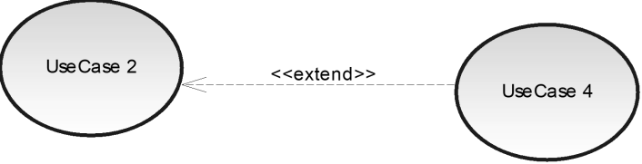 | An extension denotes that an extending action may be performed while an extended action is being performed.
Generalization | 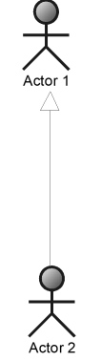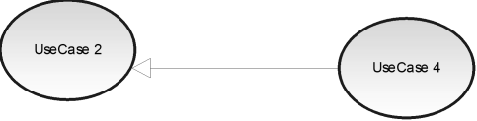 | This shows that an actor or a use case is a kind of another. Abstract or concrete actors can be defined and later specialized using generalization relationship.
System | 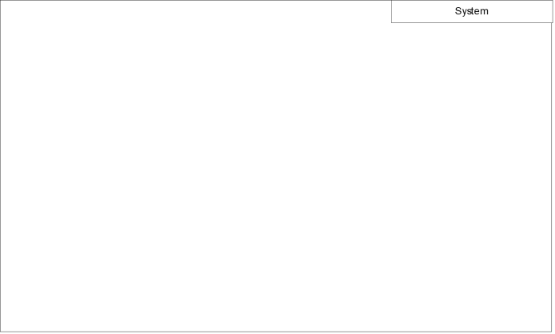 | It is a container of use cases which interact with external  actors

ACTORS OF OUR SYSTEM

Table 12: Actors of a system
Actor | Role
Customer | Register accounts for a personalized experience, search and filter listings, place orders, communicate with sellers for inquiries or negotiations, complete payments securely, track orders, and provide feedback through reviews and ratings.
VENDORS | Register and verify their accounts, list and manage products or services, handle orders and shipments, communicate with buyers, manage inventory and pricing, and receive payments securely
Admin | Approve and verify users, moderate product listings and user content, monitor transactions to prevent fraud, resolve disputes, manage payment processes, configure platform policies and settings, generate reports, and maintain community guidelines and platform security
PAYMENT API | Securely facilitate and manage financial transactions between buyers, vendors and the platform, ensuring smooth , reliable and transparent payment processing.

V. GENERAL USE CASE DIAGRAM

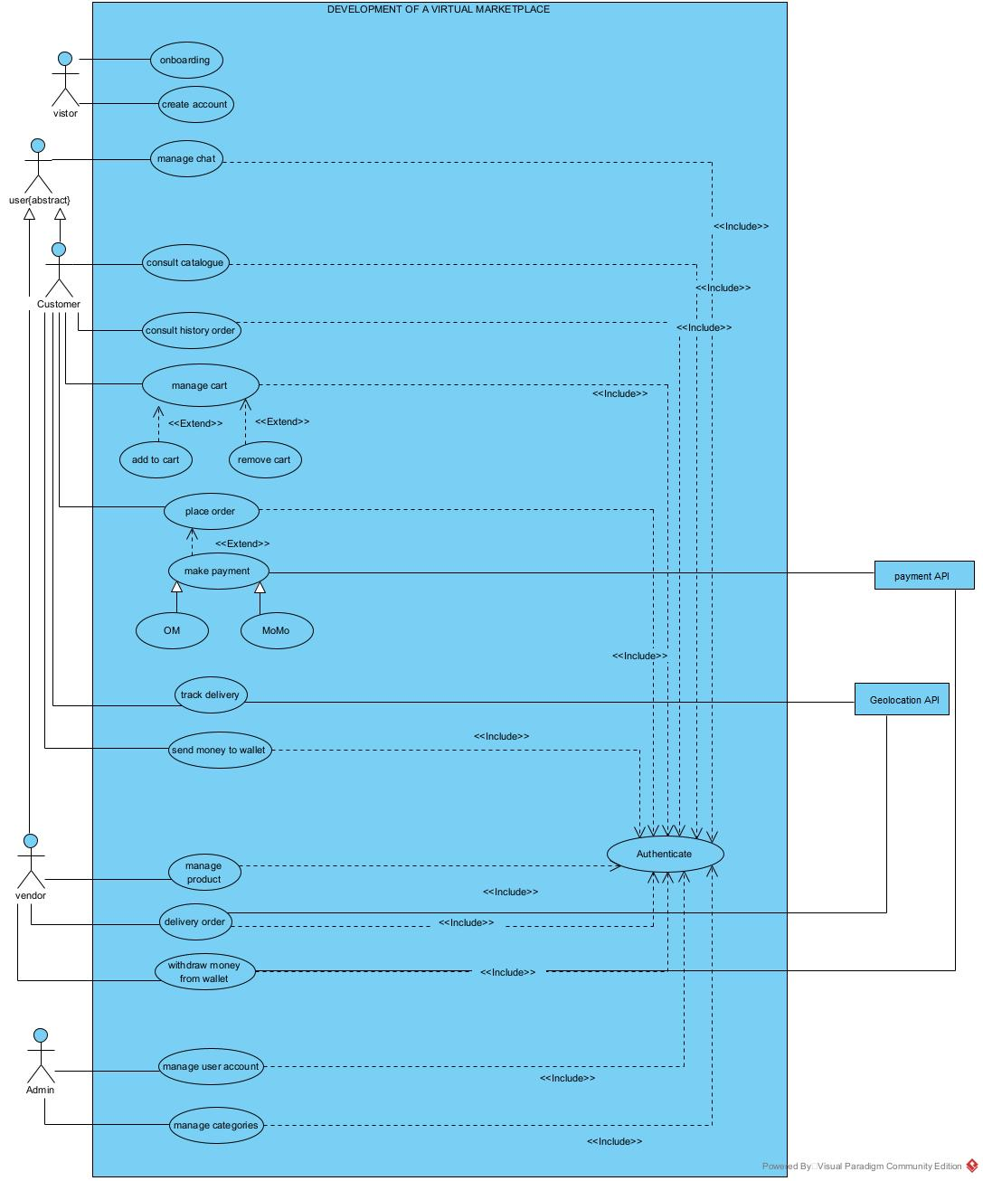
Figure 6: General use case diagram

SPECIFIC USE CASE DIAGRAM For Manage product

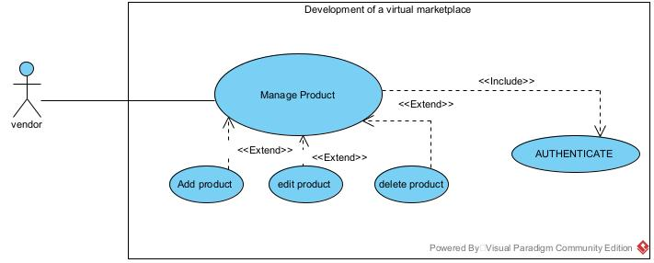
Figure 7: Specific for Manage Product

SPECIFIC USE CASE DIAGRAM For Manage User Account

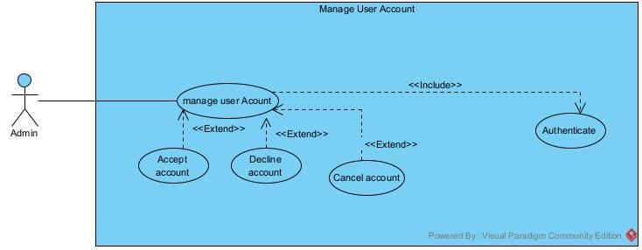
Figure 8 :Specific for Manage User Account

TEXTUAL DESCRIPTION OF USE CASES
Table 13: Authentication Textual Description
- Authentication

Title | Authenticate
Summary | The user needs to authenticate
Actors | Customer, Vendors, Admin
Version | 1.0
Precondition (s) | The app is launched.  The actor has an account on the platform.
Triggers | The user clicks on login
Nominal Scenario | - Clicks on login  - The system displays the login form.  - The actor fills and submits the form.  - The system verifies the conformity of the form fields  - The system processes the query  - The system sends the query to the database management system (DBMS).  - The database management system returns the result of the query.  - The system displays a success message to the actor.
Alternative Scenarios | - At step 3 of the nominal scenario, the actor enters mismatched or missing information.  - At step 5 the system displays an error message then returns to step 3 of the nominal scenario.
Postcondition of success | The user has access to his/her dashboard page
Postcondition of failure | The user does not have access to the platform
Non-functional requirement | The password must not be visible on the screen

COMMUNICATION DIAGRAM

DEFINITION
The communication diagram is used to model the specific interaction between the participants of the system. It describes both the static and dynamic behavior of the system. It shows the chronological succession of the actions performed by an actor to realize an operation.

FORMALISM
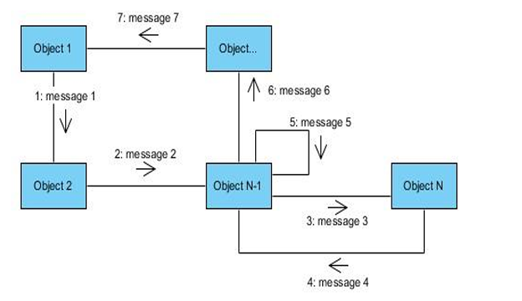
Figure 9:Formalism of Communication Diagram

COMPONENTS OF COMMUNICATION DIAGRAM
Table 14:Component of communication diagram
Element | Description | Representation
Object | Represents a role or object instance that participated in the interaction model. | 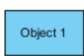
Message | Defines a particular communication between lifelines in an interaction. | 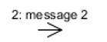
Actor | It models the type of role played by an entity that interact with the subject | 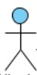
Link | It initiates an association it connects two objects together for them to communicate. | 

AUTHENTICATE COMMUNICATION DIAGRAM
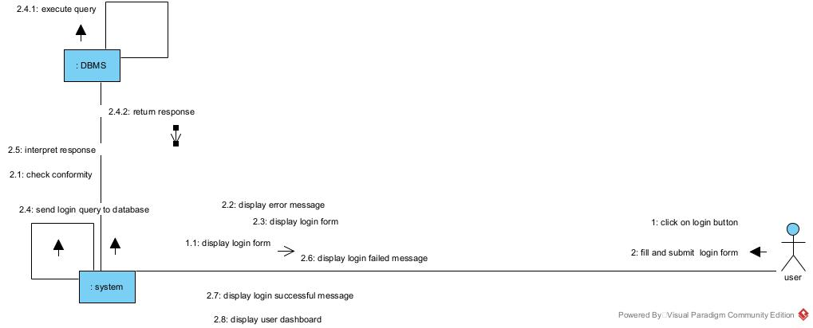
Figure 10:Communication diagram for authentication

ADD PRODUCT OF COMMUNICATION DIAGRAM

Figure 11: Add product communication Diagram
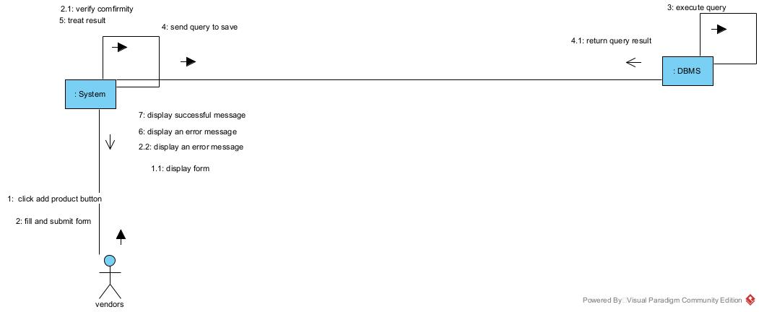

PLACE ORDER COMMUNICATION DIAGRAM
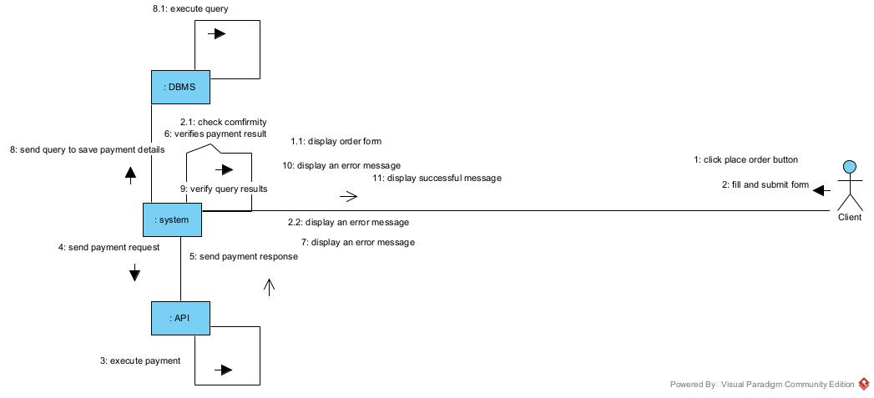
Figure 12: Place order communication Diagram

SEQUENCE DIAGRAM

DEFINITION
A sequence diagram is a UML diagram that illustrates the sequence of messages between objects in an interaction. It consists of a group of objects that are presented by lifelines and the messages that they exchange over time during the interaction. These interactions are arranged from top to bottom following their order of occurrence.

FORMALISM
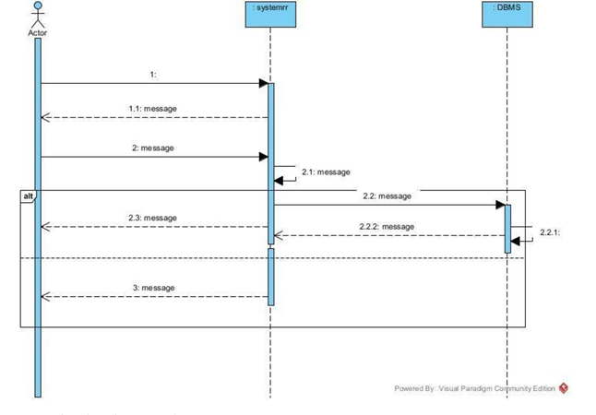
Figure 13:Formalism of sequence diagram

COMPONENTS OF SEQUENCE DIAGRAM
Figure 14:Components of a sequence diagram
Element | Description and main properties | Representation
Lifeline | They represent rows or object instances that participates in a sequence being modeled. | 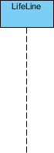
Messages | These are arrows that show the direction of message flow. We have the synchronous, the asynchronous, and the self-messages. | 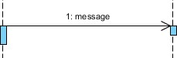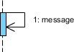
Combined Fragment | It represents a choice of behavior in which at most one operand will be chosen. | 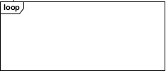
Self Message | Represents the execution or operation call on the same object
Return Message | Represents a response to a message | 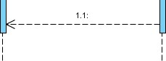
Actor | They send and receive messages.
Object | They send and receive messages

AUTHENTICATE SEQUENCE DIAGRAM
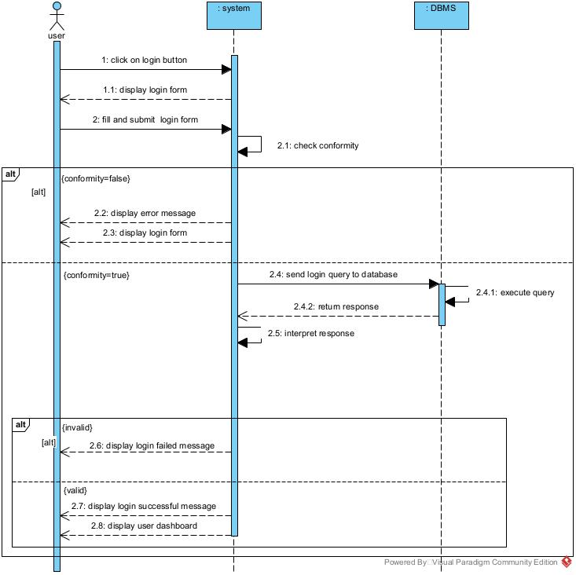
Figure 15: Authenticate Sequence Diagram

ADD PRODUCT SEQUENCE DIAGRAM
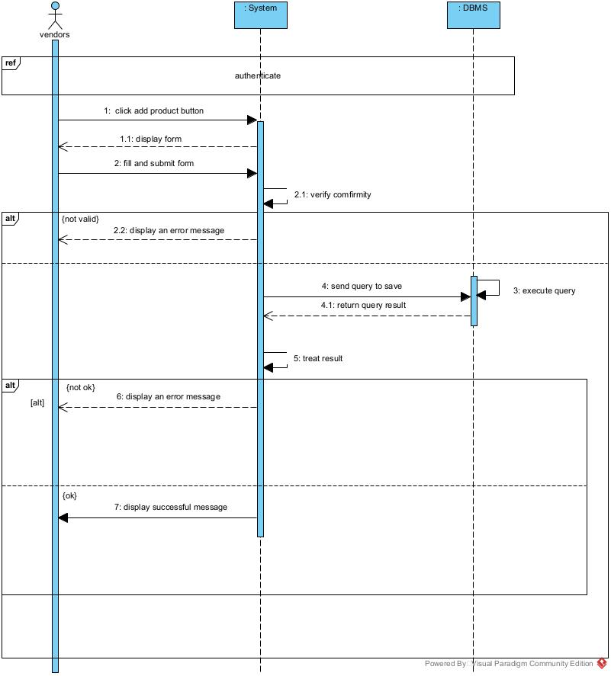
Figure 16: ADD PRODUCT Sequence Diagram

PLACE ORDER SEQUENCE DIAGRAM
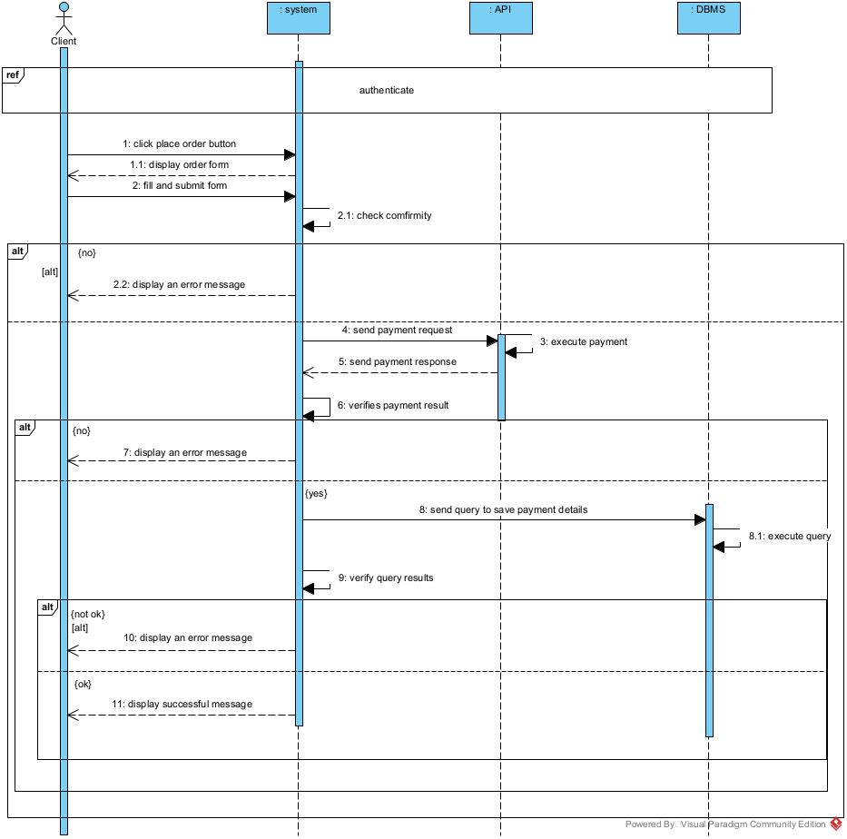
Figure 17: Place order sequence Diagram

ACTIVITY DIAGRAM

DEFINITION
An activity diagram is a graphical representation of workflows that show the steps needed in the realization of a process, showing the details from a start point to an end point through all decisions and actions that can possibly be performed. Activity diagrams are intended to model both the computational and organizational processes. The flow can be sequential, branched, or concurrent. Below is an activity diagram formalism.

FORMALISM
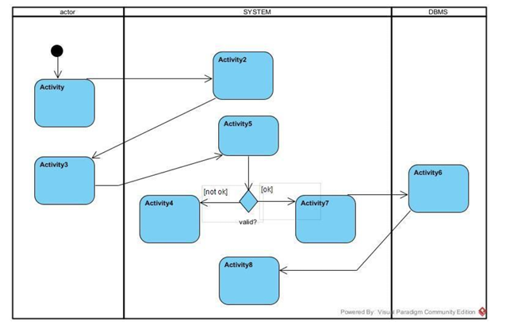
Figure 18:Formalism of an Activity diagram

COMPONENTS OF ACTIVITY DIAGRAM
Table 15:Components of an Activity Diagram
Elements | Description | Representation
Activity | It describes the action of an object and it is represented by rectangle with | 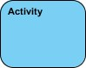
Activity edge | A directed connection between two activity nodes through which tokens may flow.
Decision node | Represent a test condition to ensure that the control flow or object flow only goes down one path | 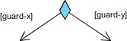
Initial Node | It is a control node at which the flow starts when an activity is invoked
Final Node | A control node that stops all flows in an activity. It is represented by a circle with a filled circle inside
Action | Represents a single step in an activity that cannot be further decomposed. | 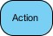
Merge node | Reunite different decision paths created using a decision node. | 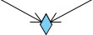
Fork node | Splits behavior into parallel or concurrent flows of activities (or actions) | 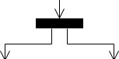
Join node | Unites a set of parallel or concurrent flows of activities or actions. | 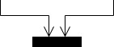
Swimlane and partition | A way of grouping activities performed by the same actor in an activity diagram or to group actions in the same thread. | 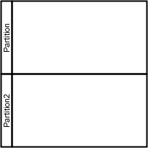

ACTIVITY DIAGRAM OF AUTHENTICATE
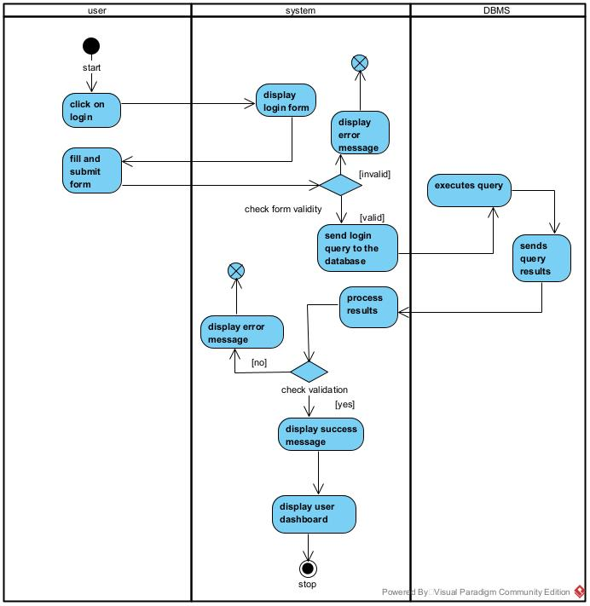
Figure 19: Authenticate Activity Diagram

ADD PRODUCT ACTIVITY DIAGRAM
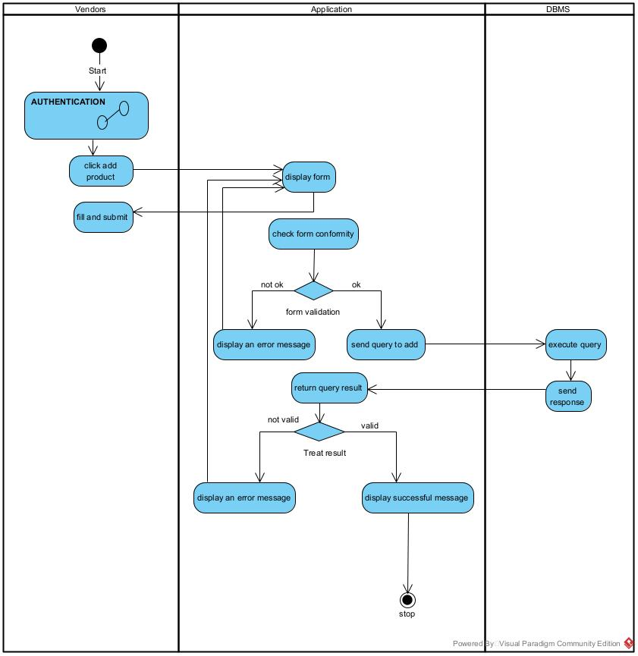
Figure 20: Add product activity diagram

PLACE ORDER OF ACTIVITY DIAGRAM
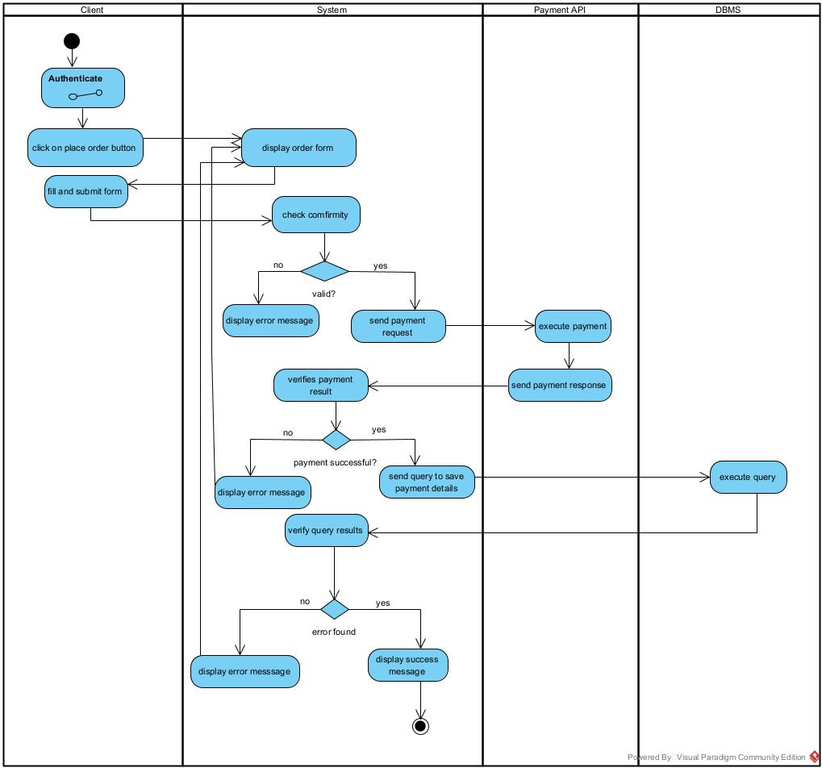
Figure 21: Place order activity Diagram

CONCLUSION
Having reached the end of our analysis, we were asked to illustrate the language and method used during this phase, present the different diagrams of the functional branch. we can then say that this analysis file has allowed us delimit the functional needs of the web application that will be designed and to have a detailed overview of the new system to be set up without notwithstanding we quickly dive into the conception phase.

FILE 4 : CONCEPTION PHASE
Preamble

This document makes it possible to model the proposed solution as a whole and to gather the information necessary to set up a complex and efficient database. It therefore foresees the future system.

Content

INTRODUCTION
- CAPTURE OF TECHNICAL NEEDS
- CLASS DIAGRAM
- STATE MACHINE DIAGRAM
- PACKAGE DIAGRAM
CONCLUSION

INTRODUCTION
The realization of an analysis file is very important for the advancement of the application, it guarantees the reliability of maintenance and use of a software. That said, after analyzing our system, we will move on to the design of our future system. To do this we will follow the steps of the technical branch of the 2TUP process, making the diagrams associated with these steps namely the class diagram and the state machine diagram.

CAPTURE OF TECHNICAL NEEDS

PHYSICAL ARCHITECTURE
The design of the DBMS depends on its architecture. An n-tier architecture partitions on the whole system into related but separated n modules, which can be independently modified, altered, changed or replace. A large amount of data on web servers, personal computers (pc) and others are link with networks with the help of basic client or server architecture.
Within the scope of our project, we made use of the 3-tier architecture This architecture separate it tiers from each other based upon the user and the manipulated data in the database. Each layer has a well-defined communication interface, and the evolution of the layer is independent of the other. The 3-tier of our system is made up of:
The client tier, which is also known as our presentation interphase.
Application Tier, which represents our webserver.
- The data tier, which represents our DBMS server


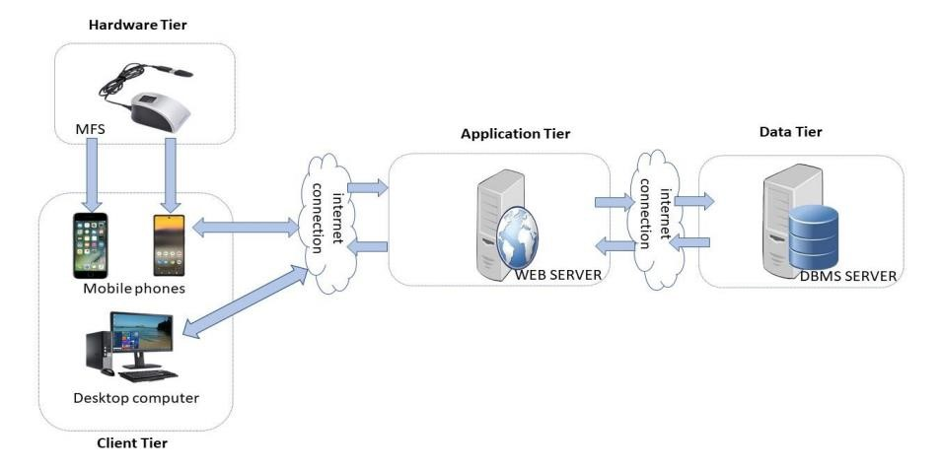

Figure 22: n-tier Architecture

LOGICAL ARCHITECTURE
Model View Controller, commonly referred to as MVC, is a software design pattern used for building applications. This pattern consists of three main components: the model, the view, and the controller.
- Model: The lowest level of the pattern, which is responsible for maintaining the data.
- View: This is responsible for displaying all or a portion of the data to the user.
- Controller: It handles software code that controls the interactions between the model and the view.
MVC is popular as it isolates the application logic from the user interface and supports the separation of concerns. Here, the controller receives all requests for the application and then works with the model to prepare data needed by the view. The view then uses the data prepared by the controller to produce a final response. The MVC can be represented as follows :
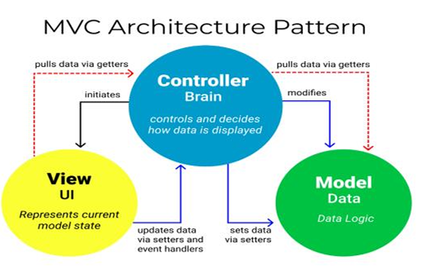
Figure 23: Logical Architecture

CLASS DIAGRAM

DEFINITION
A class diagram is a static diagram. It represents the static view of an application. class diagram are not only used for visualizing, describing, and documenting different aspects of the system, but also for constructing executable code of the software application. A class diagram describes the attributes and operations of a class and constraints imposed on the system. Its purpose is to model the static view of an application.

FORMALISM
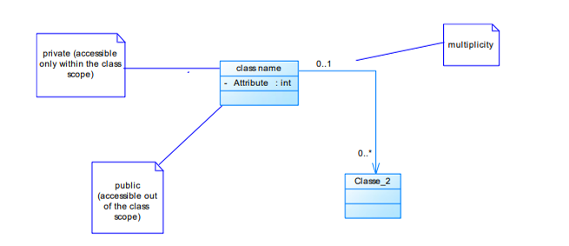
Figure 24: Formalism of a class diagram

COMPONENTS OF CLASS DIAGRAM
Table 16:Component of a class diagram
Elements | Description | Representation
Class | A class is an element that defines the attributes and behaviors that an object can generate. | 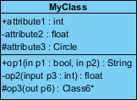
Composition | If a parent of a composite is deleted, usually, all its parts are deleted with it. | 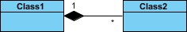
Aggregation | If the parent of the aggregate is deleted, usually the children are not deleted. | 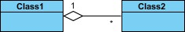
Dependency | It existed between two classes; if one changes it may cause a change in the order, but not the other way around. | 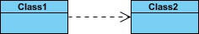
Generalization | It is a relationship between a whole thing (called a superclass) and a more specific thing (called a subclass) | 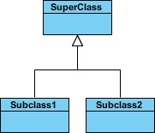
Association | It is a general type of relationship between elements; it may include cardinality, roles, etc. | 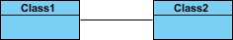

CLASS DIAGRAM OF EKANI
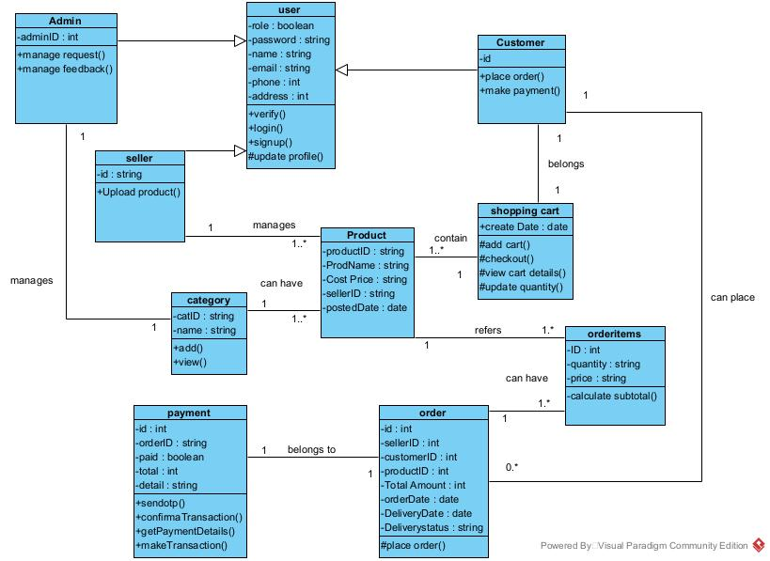
Figure 25: Ekani class diagram

STATE MACHINE DIAGRAM

DEFINITION
A class diagram is a static diagram. It represents the static view of an application. Class diagrams are not only used for visualizing, describing, and documenting different aspect of the system, but also for constructing executable code of the software application. A class diagram describes the attribute and operation of a class and constraints imposed on the system. Its purpose is to model the static view of an application.

FORMALISM
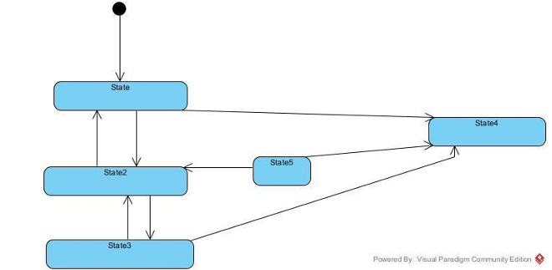
Figure 26: Formalism of a State machine diagram

COMPONENTS OF STATE MACHINE DIAGRAM
Table 17: Components of a State machine diagram
Elements | Description | Representation
Final state | A state specifying that the enclosing region is  complete
First (Initial State) | It represents a default vertex, that is, a source for a single transaction to the default or composite state.
State | Models a situation in which a certain invariant condition holds. | 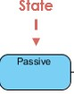
Transition | A direction relation between a source and a target vertex. | 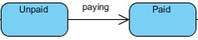
Choice pseudo state | A diamond symbol that indicates a dynamic condition with branched  potential results
Terminate | Implies that the execution of a state by means of its context is terminated.

STATE MACHINE DIAGRAM OF USER ACCOUNT
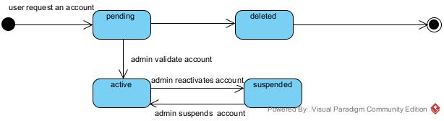
Figure 27:User account state machine Diagram

PACKAGE DIAGRAM

DEFINITION
They are structural diagrams used to show the organization and arrangement of various model elements in the form of a package. A package diagram is a group of related UML elements such as diagrams, documents, classes, or even other packages. Package diagrams are commonly used to provide a visual organization of the architectural layout within any UML classifier, such as software systems.

FORMALISM
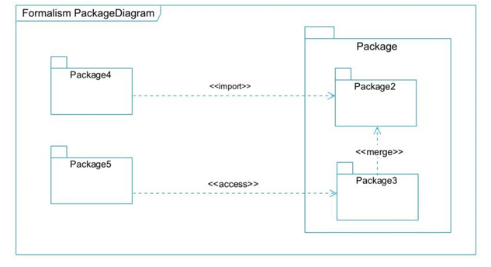
Figure 28:Formalism of a package diagram

COMPONENTS OF PACKAGE DIAGRAM
Table 18: Components of a package diagram
Elements | Description | Representation
Package | It is a namespace used to group together logically related elements within a system. Each element within the package should be a packageable element and have a unique name. | 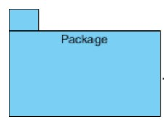
Package import | A relationship indicates that functionality has been imported from one package to another. | 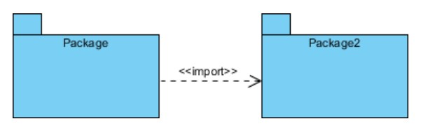
Package access | A relationship indicates that one package requires assistance from the function of another package. | 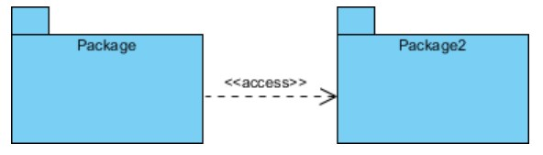
Package merge | It is a relationship which shows that the functionality of two packages is combined into a single function. | 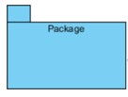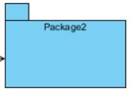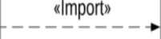

PACKAGE DIAGRAM OF EKANI

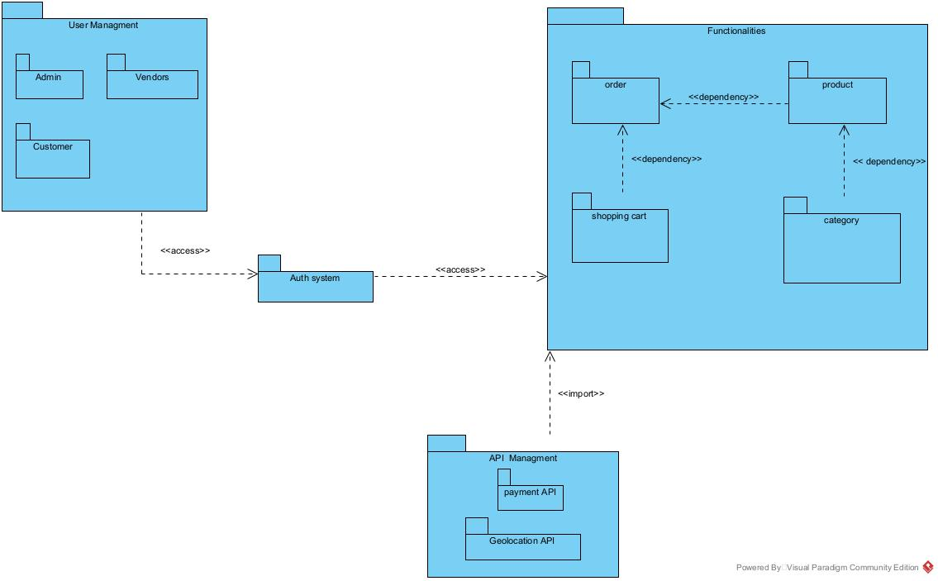
Figure 29: Package diagram of EKANI

CONCLUSION
The conception phase allowed us to bring out the data necessary for the creation of our database and the implementation of our application. The different elements modeled in this part allowed us to have a global view of the different modules of our application; therefore, the next step of our project will be the drafting of the realization file, taking into account the different elements modeled above.

FILE 5 : REALIZATION

Preamble

The realization document consists of the implementation of the project in a programming language according to the specifications defined in the previous file. It contains component and deployment diagrams, the testing and development phases. At the end of this part, programming documentation will be produced explaining the architecture of the database and the architecture of our code.

Content

INTRODUCTION
- DEPLOYEMENT DIAGRAM
- COMPONENT DIAGRAM
- TECHNICAL CHOICES
CONCLUSION

INTRODUCTION
Design and modeling are important links in the development process of an application because they make it possible to define and specify the different elements constituting the application or system studied. Realization is the culmination of the work carried out upstream because it makes it possible to physically create the various objects that were designed, and to bring the computer system to life. Throughout this phase, we will present the software, physical, and hardware architecture of our system through diagrams such as the component diagram, deployment diagram, physical model, and code architecture.

DEPLOYMENT DIAGRAM

DEFINITION
The deployment diagram models the hardware components used to implement a system and the association between those components. Deployment diagrams can be implemented as early as the design phase to document the system's physical architecture. As elements used in deployment diagrams, we can have, components, as in component diagrams, and nodes, which represent the physical processing resources of the system, and their associations.

FORMALISM
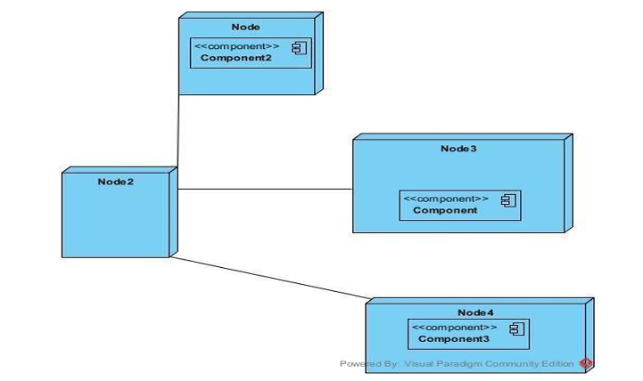
Figure 30:Formalism of a Deployment diagram

COMPONENTS OF DEPLOYMENT DIAGRAM
Table 19:Components of a Deployment diagram
Elements | Description | Representation
Component | A component represents a software entity of the system. | 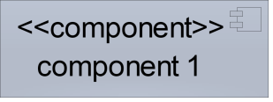
Node | A node represents a set of hardware elements of the system. A three-dimensional cube represents this entity or node. | 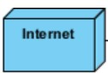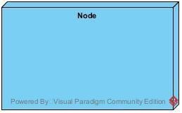
Interface | Represents a declaration of a set of coherent public features and obligations | 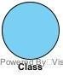
Dependency (manifestation deployment) | A relationship between two model elements where changes in one of them will similarly affect the other | 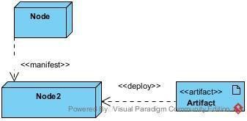
Artifact | An artifact is a major product, that is produced or used during the development of software. E.g, diagrams, data models, setup  Scripts. | 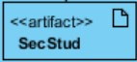

DEPLOYMENT DIAGRAM OF EKANI

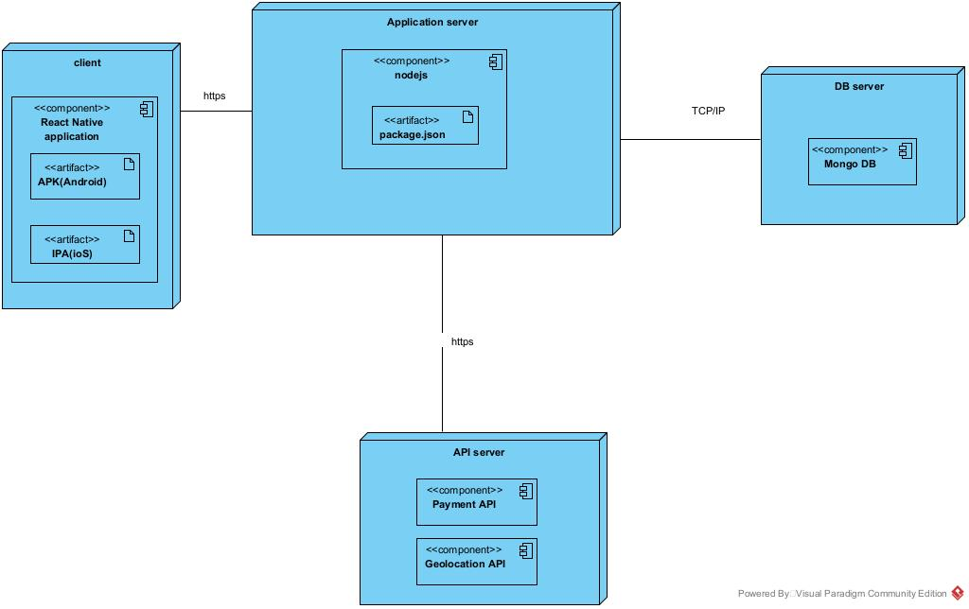
Figure 31: Deployment diagram of EKANI

COMPONENT DIAGRAM

DEFINITION
Component diagrams are used to model the physical aspect of a system. Now the question is, what is this physical aspect? They are elements such as Executables, libraries, files, documents, etc., which reside in a node. The component diagram does not describe the functionality of the system, but it describes the components used to make those functionalities.

FORMALISM
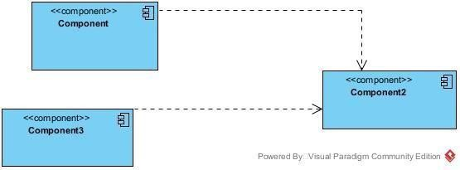
Figure 32: Formalism of a component diagram

COMPONENTS OF COMPONENT DIAGRAM
Table 20: Components of a component diagram
Element | Description and main featur |  | Representation
Component | Represents the modular part the system that encapsulates content. In other words, it is part of a system or application |  | 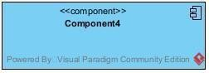
Interface | Represents a declaration of  a set of coherent  public feature  and obligations |  | 
Port | Specifies a distinct  interaction point  between that  classifier element  and environment |  | 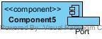
Usage | A relationship in which one element requires another element for its full  implementation or operation | 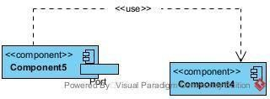
Instance Specification | It has the capability of being a deployment target in a deployment relationship | 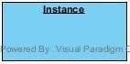

COMPONENT DIAGRAM OF EKANI

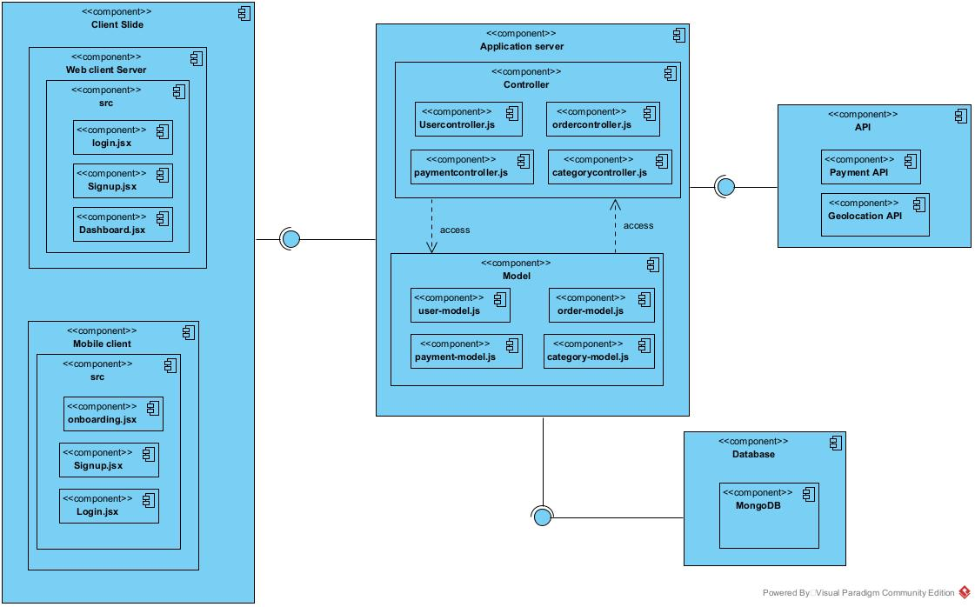
Figure 33: Component diagram of EKANI

TECHNICAL CHOICES
Table 21:Technical choices
Software | Role | Reason for use | image
OS WINDOWS 10 | The operating system required to run the software is the one on which we have worked. | Windows 10 has a user-friendly interface that is familiar to many users, making it easy to navigate and use. | 
Visual Paradigm | The software engineering workshop was used for solution modeling. We utilized this tool for modeling the various diagrams of our system | Supports multiple modeling languages and methodologies, making it suitable for various project requirements and enabling teams to adapt to different development processes. | 
Visual studio code | Visual Studio Code is a lightweight, open-source code editor developed by Microsoft, supporting multiple programming languages. Using for the writing of application code. | Combines tools for version control, debugging, and terminal access in one interface, improving efficiency and reducing the need for multiple applications. | 
Github | It is a website and cloud service that helps developers  store and manage their code. | Git allows developers to track changes, revert to previous versions, and maintain a history of modifications, ensuring that no work is lost and enabling easy recovery. | 
MS Word | MS Word is a widely used word processing application that allows users to create, edit, and format text documents. Using in-application report creation. | Offers extensive options for formatting text, images, and layouts, enabling the creation of professional quality documents. | 
MS PowerPoint | MS PowerPoint is a presentation software that allows users to create dynamic slideshows comprising text, images, videos, and animations. Able us to create slideshow presentations for application. | Its intuitive interface and templates make it easy for users to create professional presentations quickly, regardless of their technical skill level. | 
Chrome | Google Chrome is a fast, secure, and user-friendly web browser developed by Google. Used to test our application UI | Chrome is optimized for fast page loading and efficient resource management, providing a smooth browsing experience. | 
Microsoft Edge | A modern, Chromium-based web browser developed by Microsoft, offering fast performance, strong security, and seamless integration with Windows. | Optimized for Windows (better battery life, faster loading, and built-in tools like Collections and vertical tabs). | 
Gantt Project | Gantt Project is a free, open-source project management tool that allows users to create Gantt charts for planning and scheduling projects. | Allows users to assign tasks, set deadlines, and manage resources effectively, facilitating better project coordination and efficiency. | 

CONCLUSION
During our realization phase, we successfully developed and implemented our application. To achieve this, we utilized our analysis and conception phase. We also created deployment and component diagrams which illustrate the modules, files, and assets, as well as how different elements interact with each other within our system. Our next step is to move onto the functionalities testing phase, where we will assess the efficacy of the various modules present in our app for different users.

FILE 6 : FUNCTIONALITY TESTING

Preamble

This phase aims at testing the software or application to verify if the system is working as expected. It involves testing individual functionalities and capabilities of the software to ensure that they work correctly and meet the specified needs.

Content

INTRODUCTION
- APPLICATION MODULES
- TESTING
CONCLUSION

INTRODUNCTION
It is a systematic process that involves evaluating the functionality of a software application or system in different phases or stages of its development lifecycle. This testing approach ensures that each phase of the software development process is thoroughly tested for its intended functionalities and overall performance. Its main goal is to identify and rectify any defects, and bugs during the process.

APPLICATION MODULES

Authentication

This functionality enables the users to have access to their workspace or dashboard. In case he/she does not have an account, he/she will register.
- Wallet & Payment
This functionality allows customers to deposit money into their wallets and vendors to withdraw funds. It also provides transaction history, wallet balance, and secure payment operations.

Product & Category Management

This functionality enables vendors to add, update, and delete their products, while the admin manages and organizes categories. It ensures that products are properly classified for easier navigation.

Order Management

This functionality allows customers to place orders for products, track order status, and proceed through checkout. Vendors can view and manage orders received from customers.

Marketplace Browsing

This functionality enables customers to browse products, search by keywords, and filter results by categories, price, or popularity. It helps improve the shopping experience.

Notification & Communication

This functionality notifies users about wallet activities, order updates, and system alerts. It also enables communication between vendors and customers if needed.

Admin & Reporting

This functionality allows the admin to monitor activities across the platform, view analytics, and generate reports. It also helps in resolving disputes and detecting fraud.

TESTING

DEFINITION
Testing, in simple terms, involves verifying that your code functions correctly. It is important because it boosts your confidence in the code and ensures its reliability. There are different types of testing, including:
- Unit test: In a unit test, you are testing whether each function is working properly.
- Feature test: In a feature test, you are testing whether your routes, controllers, and database behave as expected.
- Manual testing: Here, you are manually testing your application.
- Alternative or Automated testing: Using tools online to test your code.

TESTS MADE IN THE SCOPE OF OUR PROJECT

CONCLUSION
Testing is an integral part of the software development life cycle and is performed to verify the correctness, reliability, and robustness of the implemented functionality. The functionality and testing phase is therefore a critical stage in software development where the implemented features are validated, and any issues are identified and resolved.

FILE 7 : USER GUIDE

Preamble

A user guide explains how to use a software application in a language that a non- a technical person can understand. Thus, it enables the user to easily use the application to familiarize themselves with the software and discover all its functionalities.

Content

INTRODUCTION
- DESCRIPTION OF THE APPLICATION
- USER MANUAL
CONCLUSION

INTRODUCTION
The user manual is the document established after the realization of an application, software or platform. It informs on the question "how to use the software, the application or the platform that you have in front of you? ". It is therefore crucial for us to offer the various users of our platform a guide allowing them to easily perform various operations on our platform.

DESCRIPTION OF THE APPLICATION
The application Ekani is a virtual marketplace platform designed to connect customers and vendors in a secure and efficient way. It integrates a digital wallet system that allows customers to deposit funds directly into their account and vendors to withdraw their earnings with ease.
Through the platform, vendors can manage their products by adding, updating, and categorizing them, while customers can browse, search, and purchase items conveniently. The system also provides an order management feature where customers can track their orders and vendors can monitor sales.
An admin dashboard is included to oversee the entire platform, manage categories, monitor transactions, and generate analytical reports. Additionally, the application ensures transparency by offering transaction history, notifications for important activities, and secure authentication for all users.
In summary, Ekani provides an all-in-one marketplace solution that enhances trust, transparency, and accessibility between vendors and customers while simplifying the overall online trading experience.

USER MANUAL

PREREQUISITES
Before using EKANI ensure you have:
• An Android smartphone/ios iPhone
• The EKANI APK file downloaded.
• A stable internet connection (for order tracking and communication).

USEFUL STEPS
- Install the Application
- Locate the downloaded EKANI APK file on your device.
- Tap on it and follow the prompts to install.
- For iOS users, download from the App Store (if available).
- Launch the Application
- Open the EKANI app from your home screen.
- Wait for the dashboard to load.
- Create an Account / Sign In
- If you are a new user, click on Register and provide your details (name, email/phone, password).
- If you already have an account, click on Login and enter your credentials.
- Set Up Your Wallet
- Navigate to the Wallet section.
- Fund your wallet using mobile money, bank card, or other supported methods.
- Check your balance before making transactions.
- Browse and Shop
- Use the search bar or category filters to explore products.
- View product details, compare items, and add desired products to your cart.
- Place an Order
- Go to your cart and proceed to checkout.
- Confirm payment using your wallet balance.
- Receive order confirmation and tracking details.
- Track Your Orders
- Go to the Order section to monitor the status (Pending, Processing, Shipped, Delivered).
- Enable notifications to get real-time updates.
- Vendor Functions (if you are a seller)
- Add or manage your products.
- Monitor customer orders.
- Request withdrawals from your wallet.
- Admin Functions (restricted to Admin users)
- Manage product categories.
- Oversee transactions and user activities.
- Generate reports and handle disputes.

Below are the steps you will have to follow to get it running on your machine:

SHOW CASE

Login Screen: Access your account securely
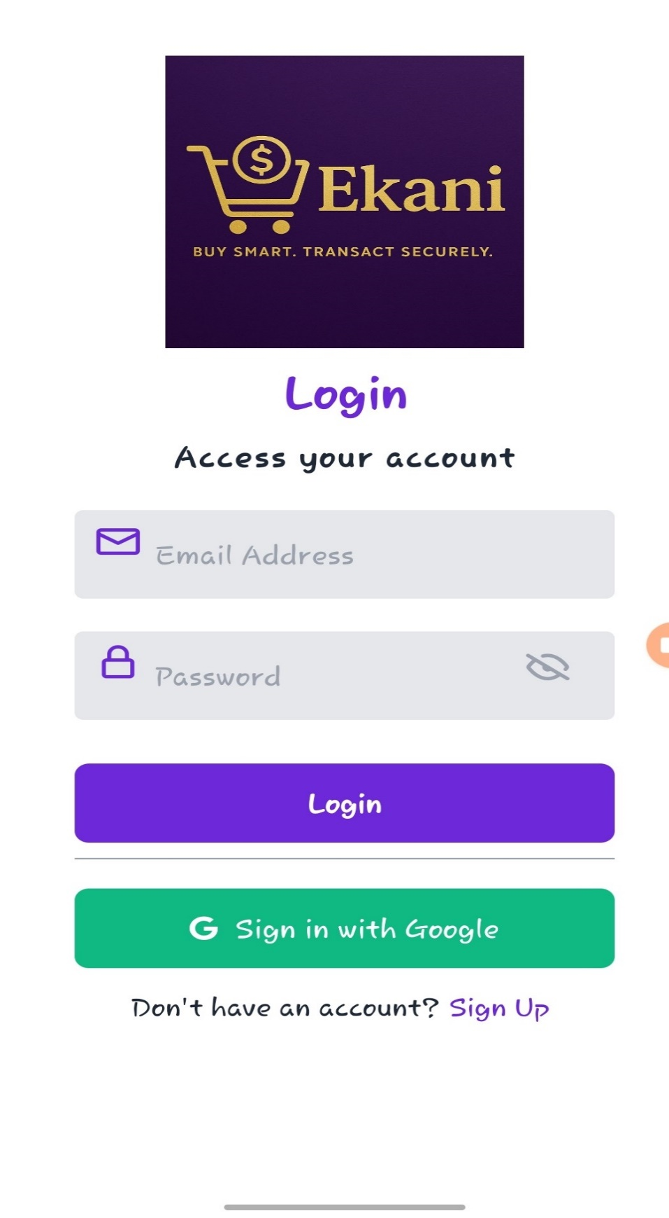Figure 34: login page

Customers page: view different product and add to cart
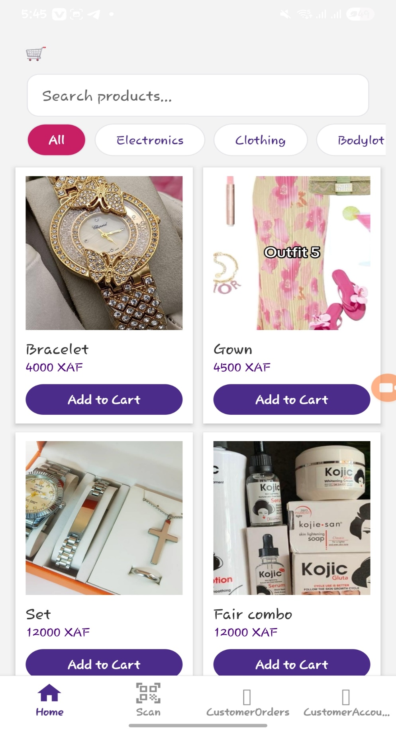
Figure 35: Customer's page

Vendor’s page : access to the product listing and order tracking.

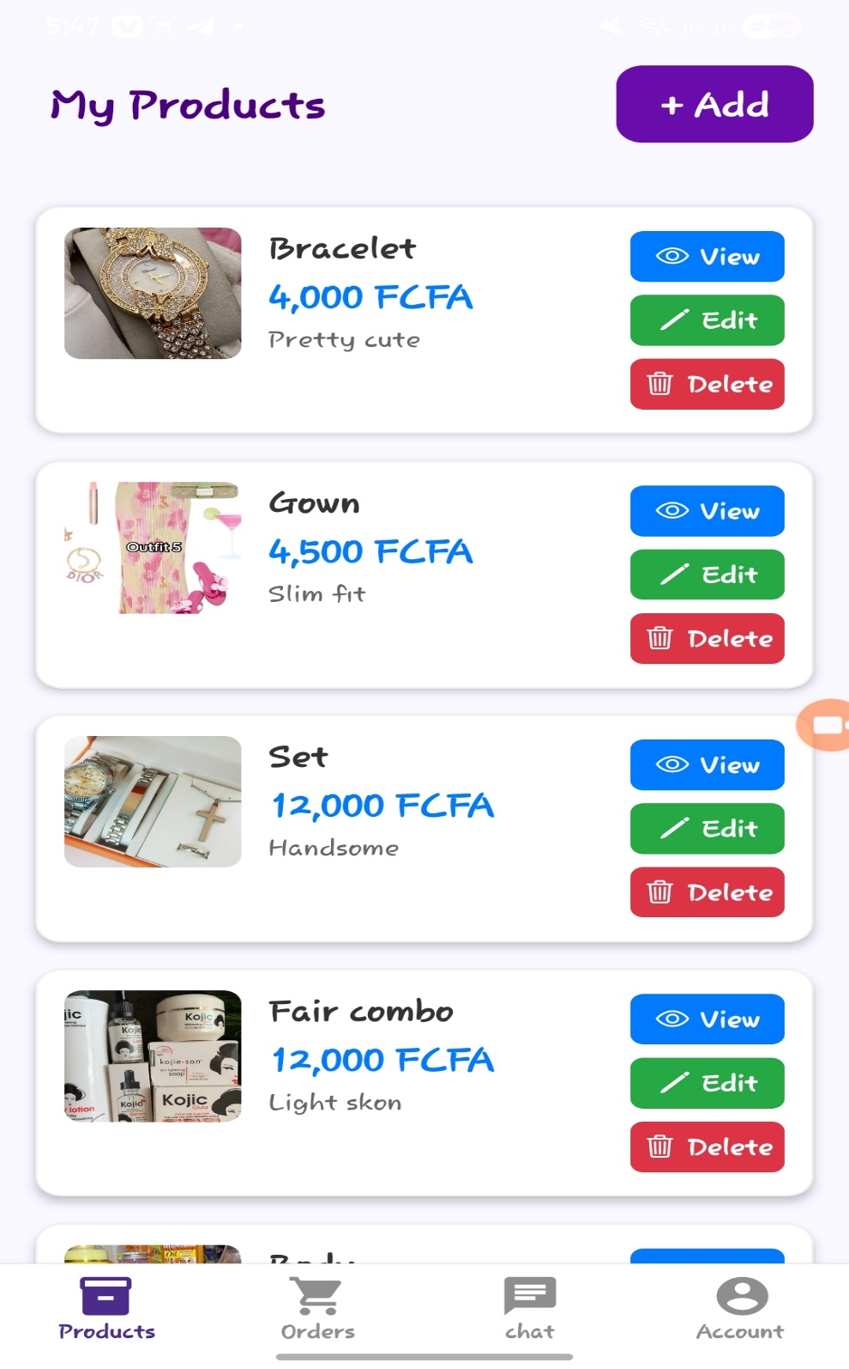
Figure 36: Vendor's page

Chat : Communication is done between vendor and customer
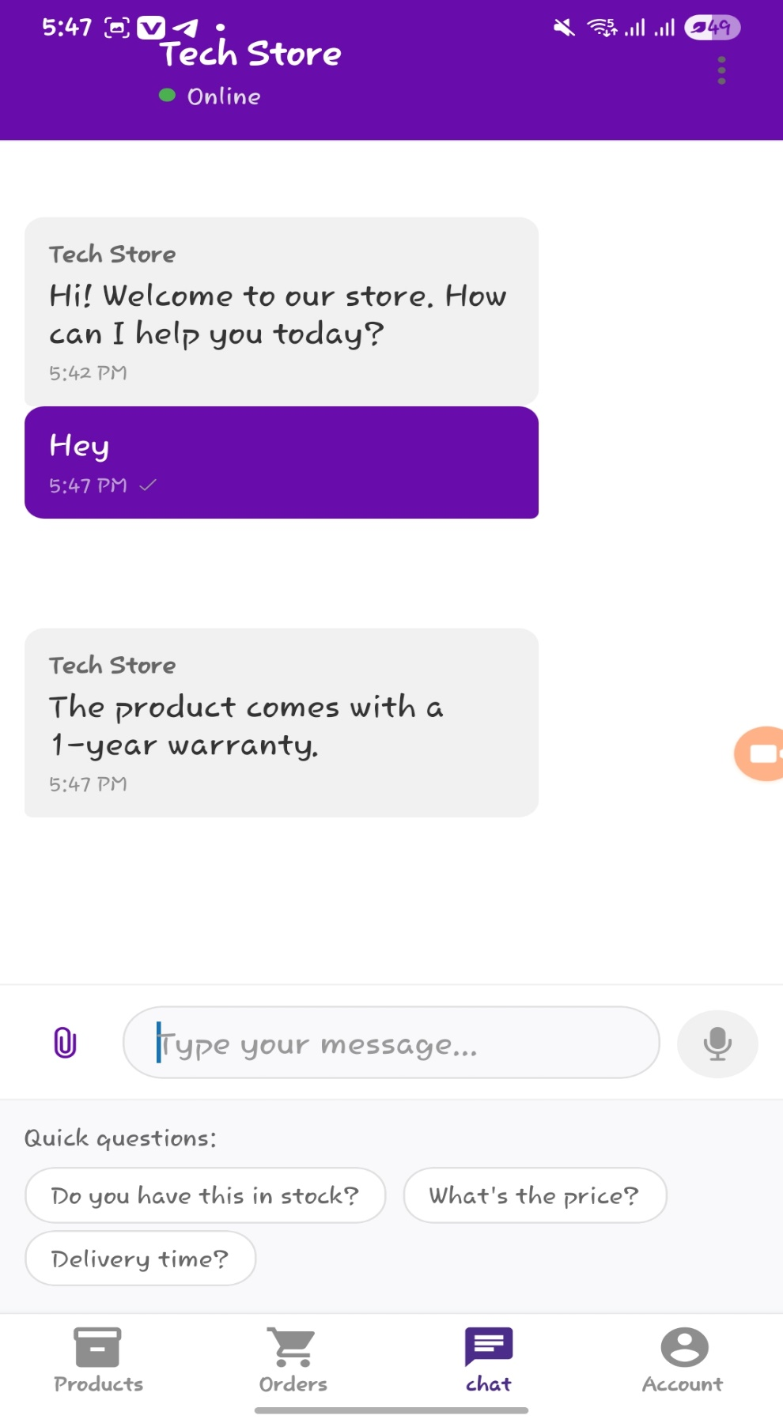Figure 37: Chat message

CONCLUSION
This user guide has provided a comprehensive overview of our product's features, functionalities, and best practices for optimal use. By following the instructions and tips outlined in this document, you'll be well-equipped to maximize the potential of our product and streamline your workflow.

PERSPECTIVES

GENERAL CONCLUSIONPERSPECTIVES

GENERAL CONCLUSIONPERSPECTIVES

GENERAL CONCLUSIONPERSPECTIVES

Having developed the main functionalities of our application, we look forward to improving various aspects, including:
- User Perspective (Customer)
- Provides an easy-to-use platform for browsing, purchasing, and tracking products.
- Offers a secure wallet system for quick deposits and payments.
- Enhances convenience by enabling order tracking and real-time notifications.
- Vendor Perspective
  - Serves as a reliable marketplace to display and manage products.
  - Simplifies sales tracking and revenue management.
  - Allows easy withdrawal of funds through the integrated wallet system.
- Administrator Perspective
  - Provides control over the platform through category management and system monitoring.
  - Ensures security by validating transactions and user activities.
  - Supports decision-making with reporting and analytics tools.
- Technical Perspective
  - Built with modern architecture ensuring scalability and security.
  - Supports integration with payment systems for smooth wallet operations.
  - Uses role-based access to ensure proper authorization and data privacy.
- Business Perspective
  - Encourages trust between vendors and customers by ensuring transparency.
  - Promotes digital trade and financial inclusion.
  - Can be expanded to include more services such as promotions, discounts, and affiliate programs.

GENERAL CONCLUSION

ANNEXESGENERAL CONCLUSION

ANNEXESGENERAL CONCLUSION

ANNEXESGENERAL CONCLUSION

The Ekani application is a secure and user-friendly virtual marketplace that bridges the gap between customers and vendors through efficient product management, seamless transactions, and real-time order tracking. With its integrated wallet system, customers can easily deposit funds while vendors withdraw their earnings conveniently, ensuring transparency and trust in the trading process. Administrators benefit from effective monitoring, category management, and reporting tools, while the system’s scalable and secure design makes it adaptable for future growth. Overall, Ekani enhances accessibility, reliability, and efficiency in online trade, making it a valuable solution for modern digital commerce.

ANNEXES

BIBLIOGRAPHYANNEXES

BIBLIOGRAPHYANNEXES

BIBLIOGRAPHYANNEXES

BIBLIOGRAPHY

WEBOGRAPHYBIBLIOGRAPHY

WEBOGRAPHYBIBLIOGRAPHY

WEBOGRAPHYBIBLIOGRAPHY

- Mercurial 2025

WEBOGRAPHY

VIDEOGRAPHYWEBOGRAPHY

VIDEOGRAPHYWEBOGRAPHY

VIDEOGRAPHYWEBOGRAPHY

- https://onetrackinternational.org/?avada_portfolio=cameroon#:~:text=According%20t o%20UNICEF%20statistics%2C%20there,no%20longer%20have%20biological%20 parents Statistics of orphans in Cameroon on June 29,2024 at 7:11pm

VIDEOGRAPHY

TABLE OF CONTENTVIDEOGRAPHY

REFERENCESVIDEOGRAPHY

TABLE OF CONTENTVIDEOGRAPHY

- https://youtu.be/Pek_tD4T3Og?si=k-O10Was_txpaciz How to send emails on your Laravel application. 7th July 2025 at 8pm
NB: TAKE NOTE OF THE STRUCTURE

REFERENCES

GENERAL INTRODUCTIONGLOSSARY

TABLE OF CONTENTREFERENCES

GENERAL INTRODUCTIONGLOSSARY

TABLE OF CONTENT

TABLE OF CONTENT

TABLE OF CONTENT

TABLE OF CONTENT

